**QUALIFICATION TEST PLAN**

«Product_Description»

PART NUMBER: «Part_Number»

| DOC REV | DESCRIPTION | SIGNATURES |
| --- | --- | --- |
| X1 | INITIAL RELEASE | Prepared by: |
| Checked by: |
| Approved by: |
| A |  | Prepared by: |
| Checked by: |
| Approved by: |
| B |  | Prepared by: |
| Checked by: |
| Approved by: |
| C |  | Prepared by: |
| Checked by: |
| Approved by: |
| D |  | Prepared by: |
| Checked by: |
| Approved by: |
| E |  | Prepared by: |
| Checked by: |
| Approved by: |

NOTICES

Latecoere Interconnection Systems US, Inc. Proprietary Notice:

The information contained herein is proprietary to Latecoere Interconnection Systems US, and shall not be disclosed or reproduced in part or in whole or used for any purpose without written authorization from Latecoere Interconnection Systems US.

This document (software) contains technical data which may be restricted for export under the Export Administration Regulations (EAR), or exported from the United States in accordance with the EAR. Diversion contrary to U.S. law is prohibited

TABLE OF CONTENTS

NOTICES 2

TABLE OF CONTENTS 3

1 INTRODUCTION 5

1.1 SCOPE 5

1.2 APPLICABLE DOCUMENTS 5

1.3 ABBREVIATIONS 6

2 QUALIFICATION TEST STATEMENTS 7

2.1 TESTS TO BE PERFORMED 7

2.2 TESTS NOT TO BE PERFORMED 8

3 TEST CONDITIONS AND TEST EQUIPMENT 9

3.1 TEST CONDITIONS 9

3.2 STANDARD AMBIENT CONDITIONS 9

3.3 TEMPERATURE STABILIZATION 9

3.4 NOMINAL INPUT POWER 9

3.5 OPERATING MODES 9

3.6 SUPPORT & TEST EQUIPMENT 10

3.7 TEST FAILURES 10

3.8 TEST REPORT 10

3.9 TEST ORDER 11

4 TEST & EQUIPMENT CONFORMITY, TEST WITNESSING, & FACILITIES 12

4.1 TEST ARTICLE FAA CONFORMITY 12

4.2 TEST SETUP FAA CONFORMITY 12

4.3 TEST WITNESSING 12

4.4 TEST FACILITIES 13

4.5 TEST LOCATIONS 14

5 TEST SETUP & PROCEDURES 15

5.1 TEMPERATURE 15

5.2 TEMPERATURE VARIATION 19

5.3 ALTITUDE 21

5.4 DECOMPRESSION 23

5.5 OVERPRESSURE 25

5.6 HUMIDITY 27

5.7 VIBRATION 30

5.8 OPERATIONAL SHOCKS 34

5.9 CRASH SAFETY IMPULSE 36

5.10 DYNAMIC BALL IMPACT *Test only required when screen size above 15-inch diagonal* 38

5.11 STATIC ABUSE LOAD *Test only required when screen size above 15-inch diagonal* 40

5.12 CRASH SAFETY SUSTAINED 42

5.13 RADIATED RF EMISSIONS 45

5.14 CONDUCTED RF EMISSIONS 47

5.15 ESD 49

5.16 POWER INPUT 51

5.17 VOLTAGE SPIKE 71

5.18 AUDIO FREQUENCY CONDUCTED SUSCEPTIBILITY 73

5.19 INDUCED SIGNAL SUSCEPTIBILITY 76

5.20 RADIATED RF SUSCEPTIBILITY 82

5.21 CONDUCTED RF SUSCEPTIBILITY 84

6 BASIC EUT TEST SETUP AND OPERATIONAL MODES 87

6.1 OPERATIONAL MODES 87

6.2 BASIC TEST SETUP 87

6.3 TEST SPECIFIC SETUPS 92

7 TEST CRITERIA 123

7.1 GROUP 1 PERFORMANCE TESTS 123

7.2 GROUP 1 PERFORMANCE MONITORING 124

7.3 VIBRATION/OPERATIONAL SHOCK TEST 125

7.4 CRASH SAFETY SUSTAINED/IMPULSE TEST 125

7.5 DYNAMIC BALL IMPACT/STATIC ABUSE LOAD TEST 125

7.6 RADIATED/CONDUCTED RF EMISSIONS 125

8 RECOMMENDED FORMS & REPORTING 126

8.1 QUALIFICATION TEST DATA SHEET TEMPLATE (optional) 126

8.2 TEST WITNESS SIGNOFF SHEET 131

9 EUT SPECIFIC DATA 132

9.1 BLOCK DIAGRAM 132

9.2 OUTLINE DRAWING 133

9.3 CONNECTOR DEFINITIONS 134

# INTRODUCTION

## SCOPE

This document contains detailed procedures and steps to take to fully verify the compliance LIS US part number: «Part_Number», herein known as Equipment Under Test (EUT), to the following paragraphs of 14 CFR 25:

* 25.305 (a)(b) (Amendment 25-23)
* 25.307 (a) (Amendment 25-23)
* 25.365(e) (Amendment 25-87)
* 25.561 (b)(c) (Amendment 25-23)
* 25.601 (Amendment 25-0)
* 25.603 (a)(b) (Amendment 25-46)
* 25.605 (Amendment 25-46)
* 25.1301 (a)(c)(d) (Amendment 25-0)
* 25.1309 (e) (Amendment 25-41)
* 25.1353 (a) (Amendment 25-42)
* 25.1431 (a) (Amendment 25-113)

## APPLICABLE DOCUMENTS

The following documents, including all revisions and amendments, form a part of this document to the extent specified herein. In the event that portions of this document conflict with the reference documents, the reference documents shall take precedence. If there is a conflict detected between the referenced applicable document & the latest document, contact the engineering department immediately.

| DOCUMENT NAME | DOCUMENT NO. | REV. | DATE | COMMENTS |
| --- | --- | --- | --- | --- |
| ENVIRONMENTAL CONDITIONS AND TEST PROCEDURES FOR AIRBORNE EQUIPMENT | DO-160 | G | 8-Dec-2010 | RTCA DOCUMENT |
| CERTIFICATION GUIDANCE FOR INSTALLATION OF NON-ESSENTIAL, NON-REQUIRED AIRCRAFT CABIN SYSTEMS & EQUIPMENT | DO-313 | - | 2-Oct-2008 | RTCA DOCUMENT |
| AIRWORTHINESS STANDARDS: TRANSPORT CATEGORY AIRPLANES | 14 CFR Part 25 | N/A | N/A | FAA DOCUMENT |
| MASTER DRAWING LIST | MDL- | - | TBD | LIS US DOCUMENT |

Table 1 – Applicable Documents

## ABBREVIATIONS

|  |  |
| --- | --- |
| AC | Alternating Current |
| AVB | Audio Video Bridge |
| DAR | Delegated Airworthiness Representative |
| EMI | Electromagnetic Interference |
| EUT | Equipment Under Test |
| FAA | Federal Aviation Administration |
| FAR | Federal Aviation Regulation |
| LCD | Liquid Crystal Display |
| LED | Light Emitting Diode |
| LRU | Line-Replaceable Unit |
| N/A | Not Applicable |
| RTCA | Radio Technical Commission for Aeronautics |
| SMART | Self-Monitoring, Analysis and Reporting Technology |
| UM | Unit Member |

Table 2 – Abbreviations

# QUALIFICATION TEST STATEMENTS

## TESTS TO BE PERFORMED

The following table summarizes the qualification tests to be performed on the EUT and the equipment category requirements: Delete this text: Remove tests and add to TESTS NOT TO BE PERFORMED AS NEEDED

| QUALIFICATION TEST | QUAL DOC / SECTION | EQUIPMENT CATEGORY | LIMITATIONS |
| --- | --- | --- | --- |
| Temperature and Altitude | DO-160G §4.5.1 | «DO160_S4_Cat» | - |
| Ground Survival Low Temperature and Short-Time Operating Low Temperature | DO-160G §4.5.1 | «DO160_S4_Cat» | *-20*°C & *-15*°C |
| Operating Low Temperature | DO-160G §4.5.2 | «DO160_S4_Cat» | *-15*°C |
| Ground Survival High Temperature and Short-Time Operating High Temperature | DO-160G §4.5.3 | «DO160_S4_Cat» | +*60*°C & +*50*°C |
| Operating High Temperature | DO-160G §4.5.4 | «DO160_S4_Cat» | +*50*°C |
| Altitude | DO-160G §4.6.1 | «DO160_S4_Cat» | *15,000* ft |
| Decompression | DO-160G §4.6.2 | «DO160_S4_Cat» | 41,000 ft |
| Overpressure | DO-160G §4.6.3 | «DO160_S4_Cat» | *-15,000* ft |
| Temperature Variation | DO-160G §5.0 | *[C]* | *2*°C/min |
| Humidity | DO-160G §6.0 | *[A]* | +*50*°C |
| Operational Shocks and Crash Safety | DO-160G §7.0 | «DO160_S7_Cat» | - |
| Operational Shocks | DO-160G §7.2 | «DO160_S7_Cat» | 11ms |
| Impulse | DO-160G §7.3.1 | «DO160_S7_Cat» | 11ms |
| Sustained | DO-160G §7.3.3 | «DO160_S7_Cat» | 9g |
| Vibration | DO-160G §8.5.2 | *[S (Curve B)]* |  |
| Power Input | DO-160G §16.0 | *[A(CF)]* |  |
| Voltage Spikes | DO-160G §17.0 | *[A]* |  |
| Audio Frequency Conducted Susceptibility | DO-160G §18.0 | *[R(CF)]* |  |
| Induced Signal Susceptibility | DO-160G §19.0 | *CN* |  |
| Radio Frequency Susceptibility | DO-160G §20.0 | *T* |  |
| Conducted RF Susceptibility | DO-160G §20.4 | *T* | 10 kHz-400 MHz |
| Radiated RF Susceptibility | DO-160G §20.5 | *T* | 100 MHz-8 GHz |
| Emission of RF Energy | DO-160G §21.0 | *M* |  |
| Conducted RF Emissions | DO-160G §21.4 | *M* |  |
| Radiated RF Emissions | DO-160G §21.5 | *M* |  |
| Electrostatic Discharge | DO-160G §25.0 | *[A]* |  |
| Flammability | DO-160G §26.0 | C |  |
| Static Abuse Load | DO-313 §4.2a | N/A |  |
| Dynamic Ball Impact | DO-313 §4.2b | N/A |  |

Table 3 – Qualification tests to be performed

## TESTS NOT TO BE PERFORMED

The following table summarizes the qualification tests to be performed on the EUT and the equipment category requirements: Remove tests and add to TESTS TO BE PERFORMED or add to this table as needed

| QUALIFICATION TEST | QUAL DOC / SECTION | REASON FOR NOT TESTING |
| --- | --- | --- |
| Explosive Atmosphere | DO-160G §9.0 | Monitor installation guidelines place EUT outside of testing categories |
| Waterproofness | DO-160G §10.0 | Monitor installation guidelines place EUT outside of testing categories |
| Fluids Susceptibility – Spray Test | DO-160G §11.0 | Test is not required per LRU installer criteria. |
| Sand and Dust | DO-160G §12.0 | Monitor installation guidelines place EUT outside of testing categories |
| Fungus Resistance *Note: Periodically, a report may be needed or requested.* | DO-160G §13.0 | Test is not required per LRU installer criteria. *See Note in QUALIFICATION TEST column.* |
| Salt Fog | DO-160G §14.0 | Monitor installation guidelines place EUT outside of testing categories |
| Lightning Induced Transient Susceptibility *Could possibly be requested or required.* | DO-160G §22.0 | Test is not required per LRU installer criteria. |
| Lightning Direct Effects | DO-160G §23.0 | Monitor installation guidelines place EUT outside of testing categories |
| Icing | DO-160G §24.0 | Monitor installation guidelines place EUT outside of testing categories |
| Grounding and Bonding *Sometimes requested by installer* | AC 25-899-1 | Test is not required due to performing during aircraft installation. |

Table 4 – Qualification test not to be performed

No tests will be performed in relation to the DO-254 or DO-178 documentation for the following reasons:

DO-254: All equipment, including electronic hardware, is tested as an assembled unit under DO-160 requirements. All equipment installed during this test is considered passed per DO-254 requirements.

DO-178: This monitor is considered non-essential flight equipment and a failure of any internal firmware/software will have no effect on the operational capabilities of the aircraft. The software level of this equipment is level E and therefore is considered out of the scope of the DO-178 requirements.

# TEST CONDITIONS AND TEST EQUIPMENT

## TEST CONDITIONS

Unless otherwise specified, test condition tolerances shall be as per DO-160G tolerances.

* Temperature: ±3°C
* Altitude: ±5% of specified pressure

## STANDARD AMBIENT CONDITIONS

### ATMOSPHERIC PRESSURE

Unless otherwise specified herein, all tests required by the specification shall be performed at an atmospheric pressure of 84Kpa to 107Kpa (24.8 to 31.6 inches of mercury).

### TEMPERATURE

Unless otherwise specified herein, all tests required by the specification shall be performed at a temperature of 25°C ±10°C.

### HUMIDITY

Unless otherwise specified herein, all tests required by the specification shall be performed at a relative humidity of 85% or less.

## TEMPERATURE STABILIZATION

### EUT OPERATIONAL

Since temperature measurement of the largest internal mass may not be practical, the minimum time considered for temperature stabilization of the EUT shall be two hours unless otherwise stated.

### EUT NON-OPERATIONAL

Since temperature measurement of the largest internal mass may not be practical, the minimum time considered applicable for temperature stabilization of the EUT shall be three hours unless otherwise stated.

## NOMINAL INPUT POWER

The term “nominal input power” as used in this procedure shall mean:

* Power input controlled to *400Hz ±10Hz/**115VAC ±5.0VAC* and/or *28VDC ±0.5VDC*

## OPERATING MODES

The EUT will operate under operating modes described in §6.1.

## SUPPORT & TEST EQUIPMENT

The following equipment is required for the tests documented by the procedure:

|  |  |  |  |
| --- | --- | --- | --- |
| ITEM | TEST EQUIPMENT DESCRIPTIONS | LIS US PART NUMBER | QUANTITY |
| VS01 | *[VIDEO SOURCE]* | *[PART NUMBER]*  (OR EQUIVALENT) | *[3]* |
| *[VD01]* | *[BLURAY OR DVD]* | *[-]* | *[3]* |
| VC01 | *[CABLE]* | *[PART NUMBER]* | *[3]* |
| PC01 | *[EUT SPECIFIC OR GENERAL EMC TEST POWER CABLE]* | *[PART NUMBER]* | *[3]* |
| PC02 | *[EUT SPECIFIC OR GENERAL POWER CABLE ASSEMBLY]* | *[PART NUMBER]* | *[3]* |
| *[-]* | *[ADDITIONAL SUPPORT EQUIPMENT]* | *[PART NUMBER]* | *[QTY]* |

Table 5 – Support test equipment

## TEST FAILURES

In the event of a test failure, the cause of the failure must be determined and the EUT repaired. Following any repair, the test which precipitated the failure and repair must be repeated. If the failure is caused by a design deficiency, a corrective action shall be developed to improve reliability. Any such action that corrects a deficiency shall be retested. For failure cases not caused by a design or fabrication deficiency but by randomly occurring failure mode, no additional action beyond normal repair will be taken.

## TEST REPORT

Data records shall be maintained and be made part of a final test report. The test report shall include test records and pictures of the test setup and the EUT taken after the test is performed. The Qualification Test Report for each test shall include a list of test equipment identified by Part Numbers, Serial Numbers and current calibration status. It is suggested that the Test Data Sheet template in §8.1 be used for test reports or at minimum the lab report contains the information requested in that template.

Where test procedures indicate to Complete §7.2 – GROUP 1 PERFORMANCE MONITORING, the test is only considered a failure when it is indicated in the PASS/FAIL CRITERIA as a requirement to be met.

## TEST ORDER

The test may be conducted in any desired order meeting the following provisions:

Crash Safety: Sustained must be tested last, after destructive tests (Ball Impact, and Static Abuse Load).

The suggested order is as follows:

*Remove tests and add to as needed*

ENV Test Order

1. Temperature
2. Temperature Variation
3. Altitude
4. Decompression
5. Overpressure
6. Vibration
7. Operational Shocks
8. Humidity
9. Crash Safety: Impulse
10. Dynamic Ball Impact
11. Static Abuse Load
12. Crash Safety: Sustained

EMC Test Order

1. Emission of Radio Frequency Energy
2. RF Susceptibility
3. Power Input
4. Audio Frequency Conducted Susceptibility
5. Induced Signal Susceptibility
6. Voltage Spikes
7. Electrostatic Discharge

# TEST & EQUIPMENT CONFORMITY, TEST WITNESSING, & FACILITIES

## TEST ARTICLE FAA CONFORMITY

*The EUT will not require FAA conformity before testing.*

OR

*Prior to any tests, all test articles shall undergo a part conformity inspection. The part conformity inspection shall occur at the manufacturer’s facility located at:*

*18047 NE 68th Street*

*Building B*

*Redmond, WA 98052*

*The conformity inspection shall be performed by an authorized FAA Delegated Airworthiness Representative (DAR) when necessary.*

*IF APPLICABLE INCLUDE:*

*A Conformity Inspection Report, FAA Form 8100-1, or/and a Statement of Conformity, FAA Form 8130-9, will be issued to document that the specimens meet the conformity requirements.* *A copy of the Statement of Conformity, FAA Form 8130-9, will be included in the test report.*

## TEST SETUP FAA CONFORMITY

*No conformity of the test setup is required before testing.*

*OR*

*Prior to [any] OR [identify specific tests that may be required] tests, [all] OR [identify specific tests that may be required] test setups shall undergo a test setup conformity inspection. The test setup conformity inspection shall occur at the test facility located at test facility or facilities specified in §4.5.*

*AND*

*The conformity inspection shall be performed by an authorized FAA Delegated Airworthiness Representative (DAR) when necessary or as determined by the UM.*

## TEST WITNESSING

*No test witnessing is required for this testing other than of LIS US representative.*

*OR*

*The qualification tests should be witnessed by the applicable UM for FAA compliance credit.*

## TEST FACILITIES

LOCATION L01

COMPANY: CKC LABS

ADDRESS: 22116 23rd Dr. SE

Bothell, WA 98021

CONTACT PERSON: KATHERINE HELGEBY

CONTACT EMAIL: Katherine.Helgeby@ckc.com

CONTACT PHONE: 425-402-1717 ext. 2100

## TEST LOCATIONS

| QUALIFICATION TEST | QUAL DOC / SECTION | LOCATION |
| --- | --- | --- |
| Temperature and Altitude | DO-160G §4.5.1 | L01 |
| Ground Survival Low Temperature and Short-Time Operating Low Temperature | DO-160G §4.5.1 | L01 |
| Operating Low Temperature | DO-160G §4.5.2 | L01 |
| Ground Survival High Temperature and Short-Time Operating High Temperature | DO-160G §4.5.3 | L01 |
| Operating High Temperature | DO-160G §4.5.4 | L01 |
| Altitude | DO-160G §4.6.1 | L01 |
| Decompression | DO-160G §4.6.2 | L01 |
| Overpressure | DO-160G §4.6.3 | L01 |
| Temperature Variation | DO-160G §5.0 | L01 |
| Humidity | DO-160G §6.0 | L01 |
| Operational Shocks and Crash Safety | DO-160G §7.0 | L01 |
| Operational Shocks | DO-160G §7.2 | L01 |
| Impulse | DO-160G §7.3.1 | L01 |
| Sustained | DO-160G §7.3.3 | L01 |
| Vibration | DO-160G §8.5.2 | L01 |
| Power Input | DO-160G §16.0 | L01 |
| Voltage Spikes | DO-160G §17.0 | L01 |
| Audio Frequency Conducted Susceptibility | DO-160G §18.0 | L01 |
| Induced Signal Susceptibility | DO-160G §19.0 | L01 |
| Radio Frequency Susceptibility | DO-160G §20.0 | L01 |
| Conducted RF Susceptibility | DO-160G §20.4 | L01 |
| Radiated RF Susceptibility | DO-160G §20.5 | L01 |
| Emission of RF Energy | DO-160G §21.0 | L01 |
| Conducted RF Emissions | DO-160G §21.4 | L01 |
| Radiated RF Emissions | DO-160G §21.5 | L01 |
| Electrostatic Discharge | DO-160G §25.0 | L01 |
| Flammability | DO-160G §26.0 | L01 |
| Static Abuse Load | DO-313 §4.2a | L01 |
| Dynamic Ball Impact | DO-313 §4.2b | L01 |

Table 6 – Test locations

# TEST SETUP & PROCEDURES

## TEMPERATURE

### PURPOSE OF TEST

Temperature tests are conducted to confirm the ability of the EUT to withstand exposure to low and high storage temperature extremes and to operate properly at specified low and high operating temperatures.

LIS US set the temperature requirements to category A4 and Temperature Levels specified in this procedure due to limitations of LCD Panel.

### TEST LEVELS

#### GROUND SURVIAL HIGH

The high ground survival temperature shall be limited to +*60*˚C.

#### SHORT-TIME OPERATING HIGH

The short-time high operating temperature shall be limited to +*50*˚C.

*If applicable, otherwise delete:* (Note: This portion of the test will not be required as OPERATING HIGH is at the same specification level.)

#### OPERATING HIGH

The high operating temperature shall be limited to +*50*˚C.

#### OPERATING LOW

The low operating temperature shall be limited to *-15*˚C.

#### SHORT-TERM OPERATING LOW

The short-time low operating temperature shall be limited to *-15*˚C.

*If applicable, otherwise delete*: (Note: This portion of the test will not be required as OPERATING LOW is at the same specification level.)

#### GROUND SURVIVAL LOW

The low ground survival temperature shall be limited to *-20*˚C.

### TEST SETUP

#### OPERATIONAL MODES

The EUT will change from operational to non-operational modes throughout the test. See Temperature plots for when each mode will be required. Degradation of performance during Operating Low is acceptable provided the EUT recovers as it ramps up to +25˚C.

#### EUT SETUP

The EUT shall be installed in the Thermal chamber with the appropriate cables and per §6.2.1.

#### ATMOSPHERIC PRESSURE

Standard Ambient Conditions as described in §3.2.1.

#### TEMPERATURE

A test temperature sensor should be installed in the chamber to capture ambient temperature.

#### HUMIDITY

Standard Ambient Conditions as described in §3.2.3.

#### TEST EQUIPMENT

The qualification test laboratory will provide the necessary equipment in order to perform the appropriate test and a list of equipment shall be documented and provided in the report.

### TEST PROCEDURE

1. Install the EUT in the test chamber and attach thermocouples.
2. Set the EUT to NORMAL OPERATION MODE per §6.1.1.
3. Complete §7.1 – GROUP 1 PERFORMANCE TESTS and record results
4. Temperature Tests shall be run using the test profiles identified in Figures 1 – 4.

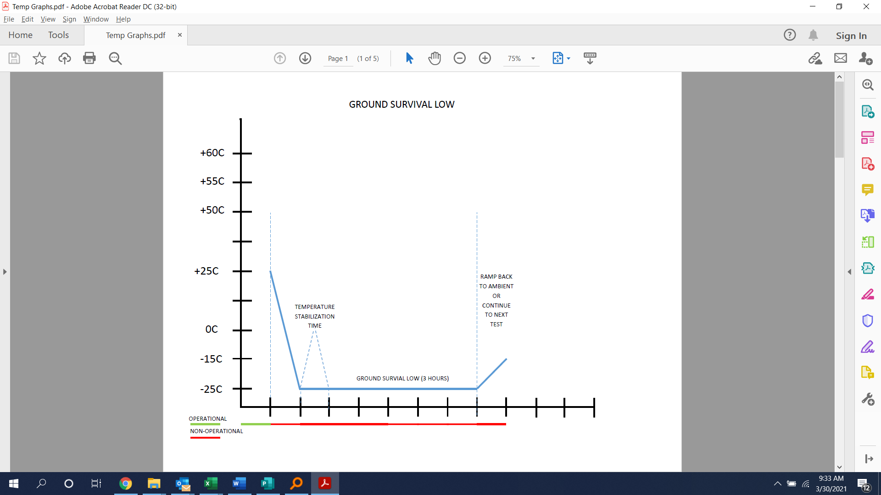

Figure 1 – Ground Survival Low

1. Do not power when NON-OPERATIONAL indicated
2. Allow for a minimum of three hours for temperature stabilization time when the EUT is indicated as NON-OPERATIONAL unless indicated otherwise
3. Ground Survival Low Temperature Test and Operating Low Temperature Test can be performed back-to-back without needing to return to +25˚C

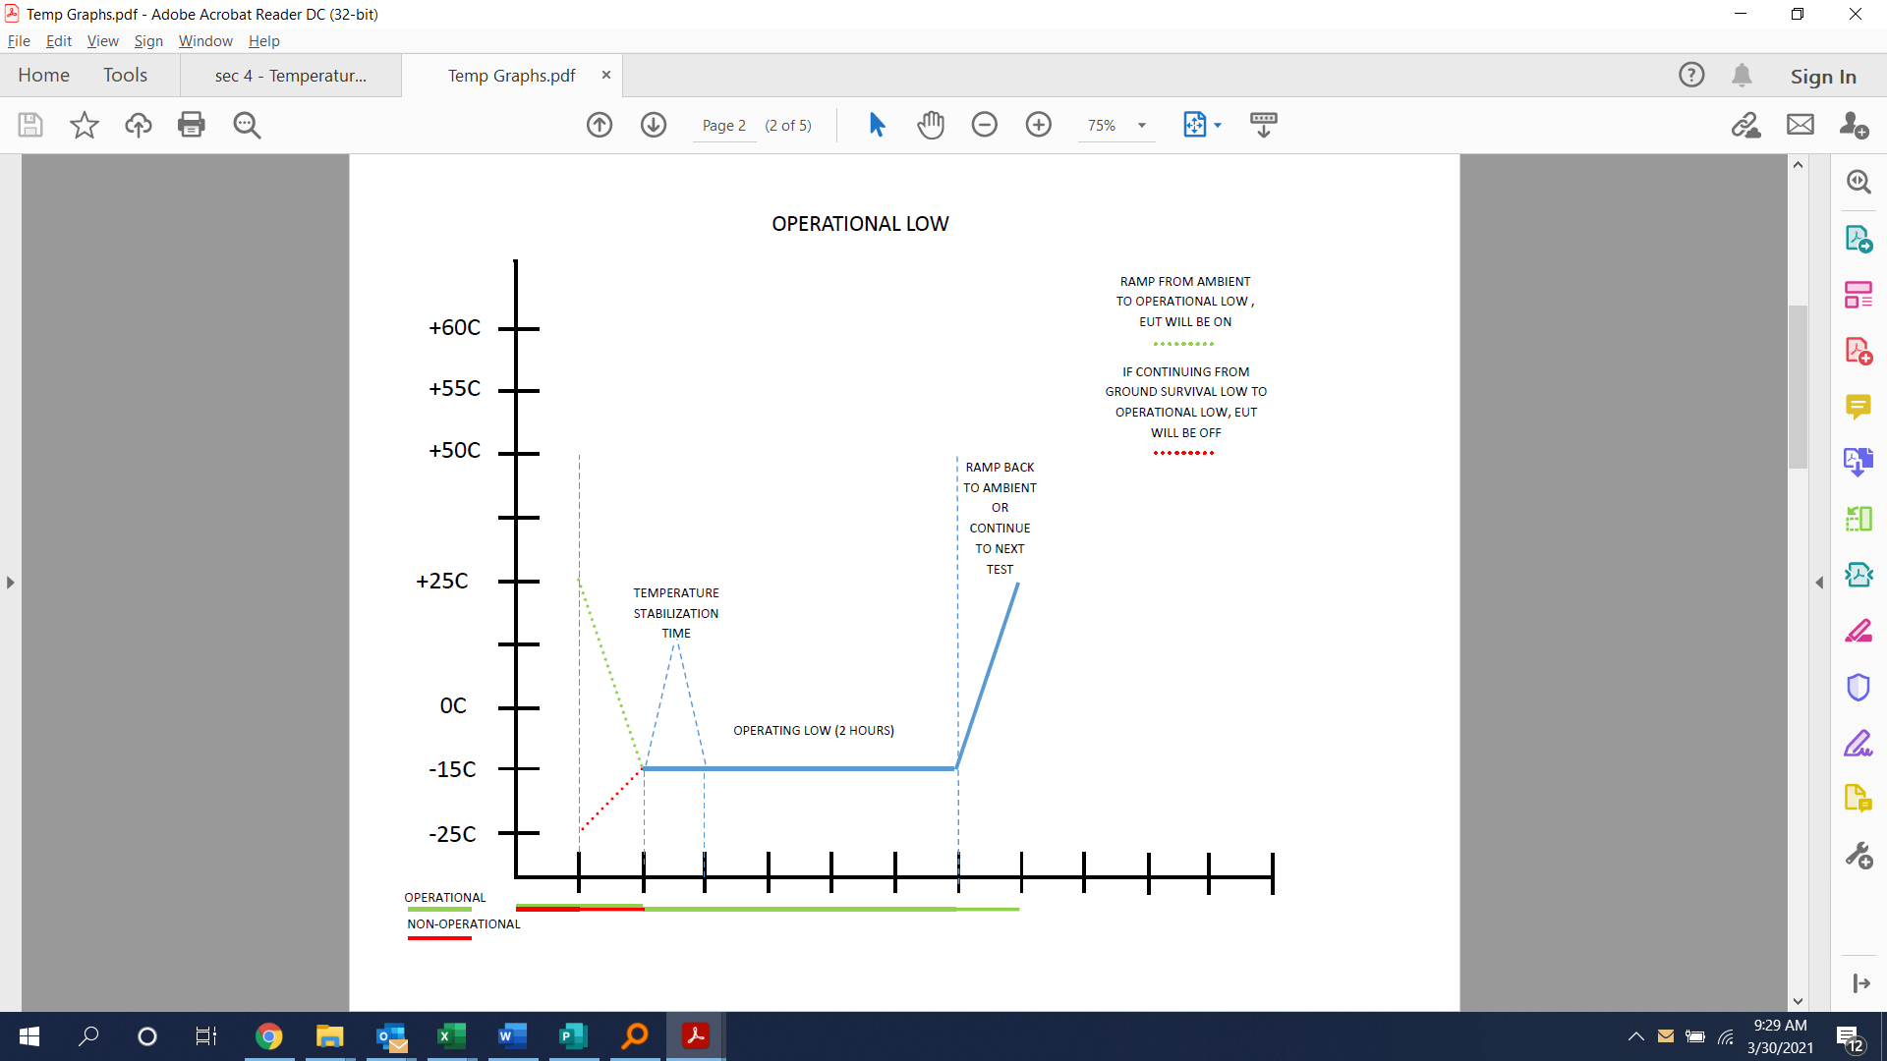

Figure 2 – Operational Low

1. Apply NORMAL OPERATION MODE per §6.1.1 while OPERATIONAL per Figure 2.
2. Allow a minimum of 2 hours for temperature stabilization time when the EUT is indicated as OPERATIONAL.
3. During operational modes greater than 30min, perform §7.2 – GROUP 1 PERFORMANCE MONITORING at least once every (1) hour.
4. Ground Survival High Temperature Test can be performed back-to-back with Operating High Temperature Test without needing to return to +25˚C after Ground Survival High.

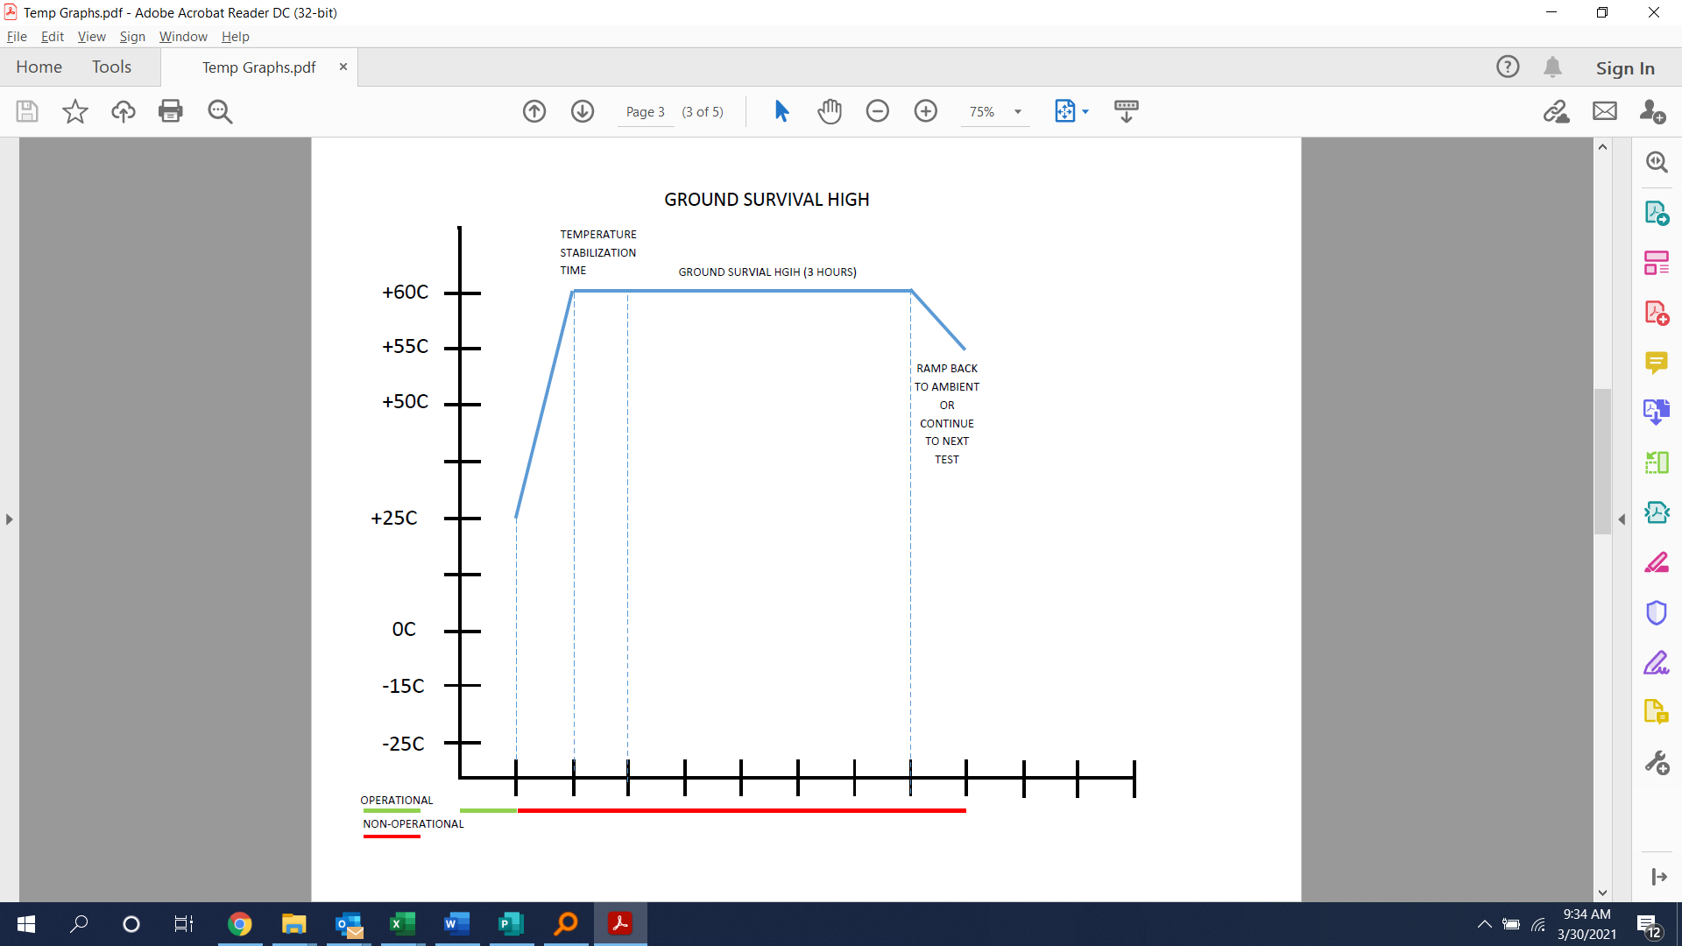

Figure 3 – Ground Survival High

1. After the last test or where each group of tests allow, 30 minutes after the test chamber has stabilized at room ambient (approximately +25˚C), perform §7.1 – GROUP 1 PERFORMANCE TESTS and record the results.

### PASS/FAIL CRITERIA

The EUT shall meet the criteria identified in §7.1 & §7.2.

*Note: Degradation of performance during Operating Low is acceptable provided the EUT recovers as it ramps up to +25˚C.*

## TEMPERATURE VARIATION

### PURPOSE OF TEST

The Temperature Variation test is conducted to confirm the ability of the EUT to withstand exposure to low and high storage temperature extremes and to operate properly at specified low and high operating temperatures.

### TEST LEVELS

#### OPERATING HIGH

The high operating temperature shall be limited to +50˚C.

#### OPERATING LOW

The low operating temperature shall be limited to -15˚C.

### TEST SETUP

#### OPERATIONAL MODES

The EUT will change from operational to non-operational modes throughout the test. See Temperature plots for when each mode will be required. Degradation of performance during Operating Low is acceptable provided the EUT recovers as it ramps up to +25˚C.

#### EUT SETUP

The EUT shall be installed in the Thermal chamber with the appropriate cables and per §6.2.1.

#### ATMOSPHERIC PRESSURE

Standard Ambient Conditions as described in §3.2.1.

#### TEMPERATURE

A test temperature sensor should be installed in the chamber to capture ambient temperature.

#### HUMIDITY

Standard Ambient Conditions as described in §3.2.3.

#### TEST EQUIPMENT

The qualification test laboratory will provide the necessary equipment in order to perform the appropriate test and a list of equipment shall be documented and provided in the report.

### TEST PROCEDURE

1. Attach thermocouples
2. Install the EUT in the test chamber
3. Set the EUT to NORMAL OPERATION MODE per §6.1.1.
4. Complete §7.1 – GROUP 1 PERFORMANCE TESTS and record results
5. Start with the EUT operating at ambient temperature (+25°C).
6. Lower the temperature to OPERATING LOW (*-15*°C) with a rate of at least 2˚C/minute.
7. Allow a minimum of 2 hours for the EUT temperature to stabilize with the chamber temperature at OPERATING LOW (*-15*°C).
8. Raise the temperature to OPERATING HIGH (+*50*°C) with a rate of at least 2˚C/minute.
9. Perform §7.2 – GROUP 1 PERFORMANCE MONITORING during temperature transition.
10. Allow a minimum of 2 hours for the EUT temperature to stabilize with the chamber temperature at OPERATING HIGH (+*50*°C).
11. Turn the EUT off for a minimum of 2 min.
12. Turn the EUT back on.
13. Lower the temperature to OPERATING LOW (*-15*°C) with a rate of at least *2*˚C/minute.
14. Perform §7.2 – GROUP 1 PERFORMANCE MONITORING during temperature transition.
15. Allow a minimum of 2 hours for the EUT temperature to stabilize with the chamber temperature at OPERATING LOW (*-15*°C).
16. Keep operating the EUT for another (1) hour.
17. Turn the EUT off for 30 min.
18. Turn the EUT back on.
19. Raise the temperature to ambient (+25°C) with a rate of at least *2*˚C/minute.
20. Go back to step 2 and perform the whole cycle again.
21. The second cycle can be performed within 24 hours of first cycle with the EUT unpowered at ambient conditions to accommodate test facility and personnel schedules.
22. At ambient temperature (+25°C) at the end of second cycle, complete §7.1 – GROUP 1 PERFORMANCE TESTS and record results

### PASS/FAIL CRITERIA

The EUT shall meet the criteria identified in §7.1 & §7.2.

*Note: Degradation of performance during Operating Low is acceptable provided the EUT recovers as it ramps up to +25˚C.*

## ALTITUDE

### PURPOSE OF TEST

The altitude test is conducted to determine the ability of the EUT to withstand decreased pressures that can be encountered during normal service usage.

### TEST LEVELS

The altitude level shall be at an equivalent of *15,000* feet (*[57.181]*kPa) above sea level.

### TEST SETUP

#### OPERATIONAL MODES

The EUT will remain in NORMAL OPERATIONAL MODE per §6.1.1 throughout the test.

#### EUT SETUP

The EUT shall be installed in the Altitude chamber with the appropriate cables and per §6.2.1.

#### ATMOSPHERIC PRESSURE

The chamber pressure shall be controlled and recorded throughout the test.

#### TEMPERATURE

Standard Ambient Conditions as described in §3.2.2.

#### HUMIDITY

Standard Ambient Conditions as described in §3.2.3.

#### TEST EQUIPMENT

The qualification test laboratory will provide the necessary equipment in order to perform the appropriate test and list of equipment shall be documented and provided in the report.

### TEST PROCEDURE

1. Attach the thermocouple on the back side of the test unit, near the center
2. Install the EUT in the test chamber.
3. Set the EUT to NORMAL OPERATIONAL MODE per §6.1.1.
4. Complete §7.1 – GROUP 1 PERFORMANCE TESTS and record results.
5. With the EUT energized, decrease the test chamber pressure to a simulated altitude of 15,000 feet (*[57.181]* kPa) above sea level.
6. Allow a minimum of 2 hours for the EUT temperature to stabilize.
7. After the EUT temperature has stabilized, continue operating the EUT for a minimum of 2 hours. Complete §7.2 – GROUP 1 PERFORMANCE MONITORING after 1 hour of this period and record the results.
8. With the EUT still operating, return the test chamber pressure to ambient pressure.
9. Complete §7.1 – GROUP 1 PERFORMANCE TESTS and record the results.
10. Visually examine the EUT for discrepancies caused by the test and record the results on a visual inspection data sheet which shall be provided in the test report.

### PASS/FAIL CRITERIA

The EUT shall meet the criteria identified in §7.1 & §7.2.

## DECOMPRESSION

### PURPOSE OF TEST

The Decompression test is conducted to determine the ability of the EUT to withstand a decompression events that can be encountered during normal service usage.

### TEST LEVELS

#### INITIAL ALTITUDE

The initial altitude shall be at an equivalent of 6,000 feet (81.20 kPa) above sea level.

#### FINAL ALTITUDE

The final altitude shall be at an equivalent of *[41,000]* feet (*[14.69]* kPa) above sea level.

### TEST SETUP

#### OPERATIONAL MODES

The EUT will remain in NORMAL OPERATIONAL MODE per §6.1.1 throughout the test.

#### EUT SETUP

The EUT shall be installed in the Altitude chamber with the appropriate cables and per §6.2.1.

#### ATMOSPHERIC PRESSURE

The chamber pressure shall be controlled and recorded throughout the test.

#### TEMPERATURE

Standard Ambient Conditions as described in §3.2.2.

#### HUMIDITY

Standard Ambient Conditions as described in §3.2.3.

#### TEST EQUIPMENT

The qualification test laboratory will provide the necessary equipment in order to perform the appropriate test and list of equipment shall be documented and provided in the report.

### TEST PROCEDURE

1. Attach the thermocouple.
2. Install the EUT in the test chamber.
3. Set the EUT to NORMAL OPERATIONAL MODE per §6.1.1
4. Complete §7.1 – GROUP 1 PERFORMANCE TESTS and record results.
5. Adjust the pressure to an equivalent of 6,000 feet (81.20 kPa) and allow a minimum of 2 hours for the EUT temperature to stabilize.
6. Reduce the absolute pressure to the equivalent of *[41,000]* feet ([14.69] kPa). This reduction in pressure shall take place within 15 seconds.
7. Maintain the reduced pressure for at least 10 minutes. §7.1 – GROUP 1 PERFORMANCE TESTS, during this 10-minute time and record results.
8. Return the chamber pressure to room ambient.
9. Complete §7.1 – GROUP 1 PERFORMANCE TESTS and record the results.

### PASS/FAIL CRITERIA

The EUT shall meet the criteria identified in §7.1.

## OVERPRESSURE

### PURPOSE OF TEST

The overpressure test is conducted to determine the EUT will withstand cabin overpressures resulting from routine aircraft pressurization system testing.

### TEST LEVELS

The altitude level shall be at an equivalent of *-15,000* feet ([169.73] kPa) above sea level.

### TEST SETUP

#### OPERATIONAL MODES

The EUT will remain in NORMAL OPERATIONAL MODE per §6.1.1 throughout the test.

#### EUT SETUP

The EUT shall be installed in the Altitude chamber with the appropriate cables and per §6.2.1.

#### ATMOSPHERIC PRESSURE

The chamber pressure shall be controlled and recorded throughout the test.

#### TEMPERATURE

Standard Ambient Conditions as described in §3.2.2.

#### HUMIDITY

Standard Ambient Conditions as described in §3.2.3.

#### TEST EQUIPMENT

The qualification test laboratory will provide the necessary equipment in order to perform the appropriate test and list of equipment shall be documented and provided in the report.

### TEST PROCEDURE

1. Set the EUT to NORMAL OPERATIONAL MODE per §6.1.1.
2. Complete §7.1 – GROUP 1 PERFORMANCE TESTS and record results.
3. Turn off the EUT and remove cables
4. Install the EUT in the test chamber.
5. Subject the EUT to an absolute pressure equivalent of -15,000 ft altitude (169.73kPa) starting from ambient pressure condition. Pressure rate of change during increasing and decreasing slope shall be a minimum of 3.0 PSI/min.
6. Maintain this condition for 10 minutes.
7. Return the EUT to the ambient atmospheric pressure.
8. Complete §7.1 – GROUP 1 PERFORMANCE TESTS and record results.

### PASS/FAIL CRITERIA

The EUT shall meet the criteria identified in §7.1.

## HUMIDITY

### PURPOSE OF TEST

The humidity test is conducted to determine the resistance of the EUT to the effects of warm and humid atmospheric conditions such as can be encountered in tropical areas cooling.

### TEST LEVELS

Ensure the following per DO-160G §6.3:

* PH between 6.5 & 7.5.
* Water resistivity not less than 250,000 ohms centimeters when measured at 25°C.
* Velocity of air throughout the exposure area be between 0.5 and 1.7 m/s.

### TEST SETUP

#### OPERATIONAL MODES

The EUT will remain in NON-OPERATIONAL MODE throughout the test until completion of humidity cycles.

#### EUT SETUP

The EUT shall be installed in the Humidity chamber with the appropriate cables and per §6.2.1.

#### ATMOSPHERIC PRESSURE

Standard Ambient Conditions as described in §3.2.1.

#### TEMPERATURE

A test temperature sensor should be installed in the chamber to capture ambient temperature.

#### HUMIDITY

The chamber humidity shall be controlled per Figure 4 and recorded throughout the test.

#### TEST EQUIPMENT

The qualification test laboratory will provide the necessary equipment in order to perform the appropriate test and a list of equipment shall be documented and provided in the report.

### TEST PROCEDURE

1. Install the EUT in the Humidity test chamber.
2. Set the EUT to NORMAL OPERATIONAL MODE per §6.1.1.
3. Complete §7.1 – GROUP 1 PERFORMANCE TESTS and record results.
4. With the EUT off, stabilize the EUT at to 38±2°C and relative humidity to at least 85±4%.
5. Over a two-hour period, ±10 minutes, raise the chamber temperature to *50*±2°C and increase the relative humidity to at least 95±4%.
6. Maintain the chamber temperature at *50*±2°C. with relative humidity at least 95 ± 4%, for 6 hours.
7. During the next 16-hour period ±15 minutes, decrease the temperature gradually to 38±2°C or lower. During this period, keep the relative humidity as high as possible and do not allow it to fall below 85%.
8. The previous three steps constitute one cycle. Repeat these steps until a total of two (2) cycles (48 hours exposure) have been completed.
9. At the end of the exposure period, remove the EUT from the chamber and drain off (do not wipe) any condensed moisture.
10. Within one hour after the 2 cycles are completed, apply NORMAL OPERATIONAL MODE per §6.1.1.
11. Allow 15 minutes maximum after application of primary power for the equipment to warm up.
12. Immediately following the warm-up period, complete §7.1 – GROUP 1 PERFORMANCE TESTS and record results.

### PASS/FAIL CRITERIA

1. No corrosion
2. The coating shall show no evidence of flaking, peeling, cracking or blistering.
3. The EUT shall meet the criteria identified in §7.1.

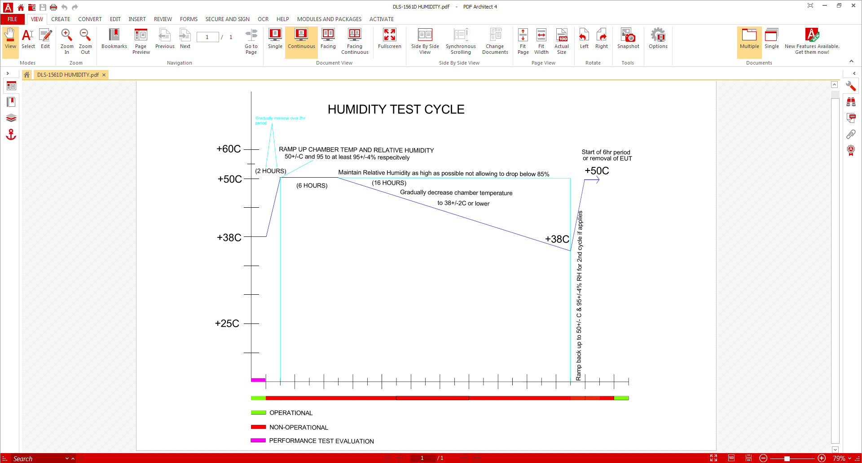

Figure 4 – Humidity Test Cycle

## VIBRATION

### PURPOSE OF TEST

Standard random vibration testing is performed to confirm the EUT is constructed with withstand expected dynamic and random vibration stresses. It is recommended vibration to be tested at the same time as operational shocks due to the same equipment and orientation being required.

### TEST LEVELS

Standard Random Vibration Test Curve B as shown in Figure 5.



Figure 5 – Standard Random Vibration Test Curve (B)

### TEST SETUP

#### OPERATIONAL MODES

The EUT will remain in NORMAL OPERATIONAL MODE per §6.1.1 throughout the test. Degradation of performance during random vibration is acceptable provided video is displayed after the test.

#### EUT SETUP

The EUT shall be mounted to the equipment using the mounting holes provided on the monitor and match the bolt size/pattern/thread/etc., of equipment provided by lab with the appropriate cables and per §6.2.1.

The EUT shall be mounted to a slip plate which will be attached to an electrodynamics’ vibration exciter (or equivalent) and connected for operation. A Mounting Block may be used if needed to attach any Mounting Brackets to the slip plate.

Two control accelerometers shall be used. These two accelerometers use the average control scheme. A response accelerometer shall be attached to the EUT as shown in each figure to measure and record the test unit’s vibration response in the axis of vibration to determine resonant frequencies and amplification factors. A control accelerometer shall be also mounted to the mounting bracket. Secure accelerometers using normal practices and perform end-to-end calibration of the accelerometer channels.

#### ATMOSPHERIC PRESSURE

Standard Ambient Conditions as described in §3.2.1.

#### TEMPERATURE

Standard Ambient Conditions as described in §3.2.2.

#### HUMIDITY

Standard Ambient Conditions as described in §3.2.3.

#### TEST EQUIPMENT

The qualification test laboratory will provide the necessary equipment in order to perform the appropriate test and a list of equipment shall be documented and provided in the report.

### TEST PROCEDURE

1. Install the EUT in the Top to Bottom axis as shown in 6.3.1.1.
2. Attach cables per §6.2.1 as well as test instrumentation, including accelerometers.
3. Set the EUT to NORMAL OPERATIONAL MODE per §6.1.1.
4. Complete §7.1 – GROUP 1 PERFORMANCE TESTS and record results.
5. Perform a 0.5 g-PK sinusoidal scan from 10Hz to 2kHz at a sweep rate not to exceed 1.0 octaves/minute.
6. Record plots of the vibration acceleration response and control at the selected positions on the equipment. Note resonant frequencies.
7. For 1 hour – run the standard random vibration test.
8. Complete §7.2 – GROUP 1 PERFORMANCE MONITORING during step 7, record the results.
9. At the beginning and end of the vibration period, perform an inspection analysis of the vibration acceleration response at the selected positions on the equipment.
10. Perform a 0.5 g-PK sinusoidal scan from 10Hz to 2kHz at a sweep rate not to exceed 1.0 octaves/minute.
11. Record plots of the vibration acceleration response and control at the selected positions on the equipment. Note resonant frequencies and any change in the EUT performance.
12. Install the EUT in the Side-to-Side axis as shown in §6.3.1.2.
13. Attach cables per §6.2.1 as well as test instrumentation, including accelerometers, as necessary.
14. Set the EUT to Normal Operation Mode
15. Complete §7.1 – Group 1 Performance Tests and record results.
16. Perform a 0.5 g-PK sinusoidal scan from 10Hz to 2kHz at a sweep rate not to exceed 1.0 octaves/minute.
17. Record plots of the vibration acceleration response and control at the selected positions on the equipment. Note resonant frequencies.
18. For 1 hour – run the standard random vibration test.
19. Complete §7.2 – Group 1 Performance Monitoring during step 7, record the results.
20. At the beginning and end of the vibration period, perform an inspection analysis of the vibration acceleration response at the selected positions on the equipment.
21. Perform a 0.5 g-PK sinusoidal scan from 10Hz to 2kHz at a sweep rate not to exceed 1.0 octaves/minute.
22. Record plots of the vibration acceleration response and control at the selected positions on the equipment. Note resonant frequencies and any change in the EUT performance.
23. Install the EUT in the Front to Rear axis as shown in 6.3.1.3.
24. Attach cables per §6.2.1 as well as test instrumentation, including accelerometers, as necessary.
25. Set the EUT to NORMAL OPERATIONAL MODE per §6.1.1.
26. Complete §7.1 – GROUP 1 PERFORMANCE TESTS and record results and record results.
27. Perform a 0.5 g-PK sinusoidal scan from 10Hz to 2kHz at a sweep rate not to exceed 1.0 octaves/minute.
28. Record plots of the vibration acceleration response and control at the selected positions on the equipment. Note resonant frequencies.
29. For 1 hour – run the standard random vibration test.
30. Complete §7.2 – GROUP 1 PERFORMANCE MONITORING during step 7, record the results.
31. At the beginning and end of the vibration period, perform an inspection analysis of the vibration acceleration response at the selected positions on the equipment.
32. Perform a 0.5 g-PK sinusoidal scan from 10Hz to 2kHz at a sweep rate not to exceed 1.0 octaves/minute.
33. Record plots of the vibration acceleration response and control at the selected positions on the equipment. Note resonant frequencies and any change in the EUT performance.
34. Complete §7.1 – GROUP 1 PERFORMANCE TESTS and record results.
35. Visually inspect the EUT for mechanical discrepancies and record results

### PASS/FAIL CRITERIA

1. The EUT shall meet the criteria identified in §7.1 & §7.3.

## OPERATIONAL SHOCKS

### PURPOSE OF TEST

The shock test is performed to determine if the EUT is constructed to withstand dynamic shock stresses that can be experienced during normal aircraft operation, and to ensure that performance degradations of malfunctions will not be produced by shocks occurring during taxing, landing, or when an aircraft encounters sudden gusts of wind in flight.

### TEST LEVELS

Each shock pulse (terminal-saw tooth) shall have nominal time duration of 11 milliseconds and an acceleration peak value of 6Gs.

### TEST SETUP

#### OPERATIONAL MODES

The EUT will remain in NORMAL OPERATIONAL MODE per §6.1.1 throughout the test.

#### EUT SETUP

Refer to §5.7.3.2.

#### ATMOSPHERIC PRESSURE

Standard Ambient Conditions as described in §3.2.1.

#### TEMPERATURE

Standard Ambient Conditions as described in §3.2.2.

#### HUMIDITY

Standard Ambient Conditions as described in §3.2.3.

#### TEST EQUIPMENT

The qualification test laboratory will provide the necessary equipment in order to perform the appropriate test and a list of equipment shall be documented and provided in the report.

### TEST PROCEDURE

1. Install the EUT on the vibration table in the Top to Bottom axis as shown in §6.3.1.1.
2. Attach cables per §6.2.1.1 as well as test instrumentation, including accelerometers.
3. Set the EUT to NORMAL OPERATIONAL MODE per §6.1.16.1.1.
4. Complete §7.1 – GROUP 1 PERFORMANCE TESTS and record results.
5. Subject the EUT to three shocks in each direction along the vertical axis. The EUT shall be operating during applications of the shocks.
6. Complete §7.1 – GROUP 1 PERFORMANCE TESTS and record results.
7. Install the EUT in the Side-to-Side axis as shown in §6.3.1.2.
8. Attach cables per §6.2.1.1 as well as test instrumentation, including accelerometers, as necessary.
9. Set the EUT to NORMAL OPERATIONAL MODE per §6.1.1.
10. Complete §7.1 – GROUP 1 PERFORMANCE TESTS and record results.
11. Subject the EUT to three shocks in each direction along the lateral axis. The EUT shall be operating during applications of the shocks
12. Complete §7.1 – GROUP 1 PERFORMANCE TESTS and record results.
13. Install the EUT in the Front to Rear axis as shown in 6.3.1.3.
14. Attach cables per §6.2.1 as well as test instrumentation, including accelerometers, as necessary.
15. Set the EUT to NORMAL OPERATIONAL MODE per §6.1.1.
16. Complete §7.1 – GROUP 1 PERFORMANCE TESTS and record results.
17. Subject the EUT to three shocks in each direction along the longitudinal axis. The EUT shall be operating during applications of the shocks
18. Complete §7.1 – GROUP 1 PERFORMANCE TESTS and record results.
19. Visually inspect the EUT for mechanical discrepancies and record results

### PASS/FAIL CRITERIA

The EUT shall meet the criteria identified in §7.1 & §7.3.

## CRASH SAFETY IMPULSE

### PURPOSE OF TEST

The crash impulse shock test is conducted to verify that the equipment will not detach from its mounting or separate in a manner that presents a hazard during an emergency landing.

### TEST LEVELS

Each shock pulse (terminal saw tooth) shall have nominal time duration of 11 milliseconds and acceleration peak value of 20G.

### TEST SETUP

#### OPERATIONAL MODES

The EUT will remain in NON-OPERATIONAL MODE throughout the test.

#### EUT SETUP

Refer to §5.7.3.2.

#### ATMOSPHERIC PRESSURE

Standard Ambient Conditions as described in §3.2.1.

#### TEMPERATURE

Standard Ambient Conditions as described in §3.2.2.

#### HUMIDITY

Standard Ambient Conditions as described in §3.2.3.

#### TEST EQUIPMENT

The qualification test laboratory will provide the necessary equipment in order to perform the appropriate test and a list of equipment shall be documented and provided in the report.

### TEST PROCEDURE

1. Visually inspect the EUT for any prior damage, note at the beginning of this test if any discrepancies and provide in the test report. Take photos of any bending that may have occurred in previous tests.
2. Install the EUT in the Top to Bottom axis as shown in §6.3.1.1.
3. Attach test instrumentation, including accelerometers, as necessary.
4. Take pre-test photograph.
5. Subject the EUT to three shocks in each direction along the vertical axis.
6. Visually inspect the EUT for mechanical discrepancies, verify there is no detachment of mounted equipment and record results.
7. Take post-test photograph.
8. Install the EUT in the Side-to-Side axis as shown in §6.3.1.2.
9. Attach test instrumentation, including accelerometers, as necessary.
10. Take pre-test photograph.
11. Subject the EUT to three shocks in each direction along the lateral axis.
12. Visually inspect the EUT for mechanical discrepancies, verify there is no detachment of mounted equipment and record results.
13. Take post-test photograph.
14. Install the EUT in the Front to Rear axis as shown in §6.3.1.3.
15. Attach cables and instrumentation, including accelerometers, as necessary.
16. Take pre-test photograph.
17. Subject the EUT to three shocks in each direction along the longitudinal axis.
18. Visually inspect the EUT for mechanical discrepancies, verify there is no detachment of mounted equipment and record results.
19. Take post-test photograph.
20. Visually inspect the EUT for any damage incurred by the test, note any discrepancies and provide in the test report. Take photos of any bending that may have occurred from tests.

### PASS/FAIL CRITERIA

1. The EUT shall meet the criteria identified in §7.4.

## DYNAMIC BALL IMPACT *Test only required when screen size above 15-inch diagonal*

### PURPOSE OF TEST

To satisfy Glass In Cabin test requirements, the EUT will complete the Ball Impact test and shall demonstrate compliance as described in this test plan. Portions of the method for this test are extracted from UL 61965. Note that since the Pass/Fail criteria of this test plan is more restrictive (no glass is allowed to be expelled from the unit) than requirements of UL 61965, the barriers and non-skid surface described in section 7.2 of UL 61965 are deemed unnecessary since any glass thrown from the EUT, irrespective of distance, is inevitably a failure.

### TEST LEVELS

The impact energy shall be 5.5 ± 0.1 Joules.

### TEST SETUP

#### OPERATIONAL MODES

The EUT will remain in NON-OPERATIONAL MODE throughout the test.

#### EUT SETUP

* The EUT shall be mounted to a rigid support base
* The panel shall be mounted vertically in position such that the impact site is located at least 40mm away from the nearest edge of the useful screen (Reference §6.3.2).
* The center of the drop radius shall be in the same plane as the screen, and the ball must be able to swing through its arc without obstruction prior to impacting the screen.
* The panel shall be subjected to one impact
* The impact energy shall be transmitted by a steel ball of (40 ± 1) mm diameter.
* A single impact shall be applied to any point of the LCD panel face at a minimum distance of 40mm from the edge of the viewable area of the screen. The ball release method must ensure that no energy is added to the ball from its release through the impact.
* The impacting ball shall be suspended from a cable, wire, or similar flexible and light material. The length of the wire (or drop radius) shall be sufficient to yield the proper impact energy when dropped from a horizontal position
* The center of the drop radius shall be in the same plane as the screen, and the ball must be able to swing through its arc without obstruction prior to impacting the screen
* Care must be taken to catch the ball after the first impact
* The drop radius (r) shall be calculated based on actual measured ball mass. The following equation may be used to calculate drop radius:

|  |  |  |
| --- | --- | --- |
| $$r=E/mg$$ |  | Where: |
|  | J |  |
|  | m/s2 |  |
|  | .260 ± .015(kg) |  |

#### ATMOSPHERIC PRESSURE

Standard Ambient Conditions as described in §3.2.1.

#### TEMPERATURE

Standard Ambient Conditions as described in §3.2.2.

#### HUMIDITY

Standard Ambient Conditions as described in §3.2.3.

#### TEST EQUIPMENT

The qualification test laboratory will provide the necessary equipment in order to perform the appropriate test and a list of equipment shall be documented and provided in the report.

### TEST PROCEDURE

1. Inspect the EUT for any damage. Pay particular attention to the mounting brackets and the glass screen.
2. If part conformity is required, verify that the test article has been conformed and that the proper FAA Form 8130-9 has been provided.
3. Install the test article on a rigid support fixture using manufacturer supplied mounting hardware according to the manufacturer’s installation instructions. The test assembly shall be mounted vertically.
4. Mark and identify with an indelible marker and unique identifying serial number the location of the intended impact test site.
5. Verify that the impact ball radius is set correctly and that the impact site dictated by the radius is located properly.
6. Verify that the center of rotation of the drop arc (that is, the fixed end of the cable or wire) is located in the same plane as the screen.
7. Conform the test article installation and setup as required.
8. Position the impacting ball such that the suspending cable or wire is horizontal.
9. Visually inspect for and document any damage.
10. Remove the test article and report all test results to the test originator.
11. Take post-test photograph of the test article.

### PASS/FAIL CRITERIA

1. Any exposed glass shall be contained inside the EUT in the event of breakage.
2. The glass is allowed to crack but cannot be expelled from the unit or create exposed sharp edges.

## STATIC ABUSE LOAD *Test only required when screen size above 15-inch diagonal*

### PURPOSE OF TEST

To satisfy Glass In Cabin test requirements, the EUT will complete the 300 Pound Abuse Load Strength and shall demonstrate compliance as described in this test plan.

### TEST LEVELS

1. The mechanism used to provide the force shall be verified to 300 pounds +1/-0 percent. This force mechanism may be dead weight, hydraulic, mechanical, or any other suitable configuration capable of repeated application of the same load, and proper load verification traceable to National Institute of Standards and Technology (www.nist.gov).
2. The load pad used to transfer the force to the display unit shall be of the geometry defined in Figure 12.
3. Care shall be taken to ensure symmetric load application across the surface of the pad even if the display screen surface displaces slightly during loading. The six-inch diameter aluminum disk transfers the load to the rubber pad.
4. A minimum of five points on the display unit shall be tested. These points shall be in locations as documented in Figure 12. Additional points may be tested if requested by the test originator.
5. The load pad shall be placed such that a gap of 0.5 ± 0.1 inches exists between the edge of the load pad and nearest edge of the front metal case of the monitor. The pad shall not come into contact with the display unit case, mounting brackets, or any other structure except the glass screen.

### TEST SETUP

#### OPERATIONAL MODES

The EUT will remain in NON-OPERATIONAL MODE throughout the test.

#### EUT SETUP

A satisfactory test setup is shown in §6.3.3.1. The alignment should be shown with circles drawn around the test application areas per §6.3.3.2.

#### ATMOSPHERIC PRESSURE

Standard Ambient Conditions as described in §3.2.1.

#### TEMPERATURE

Standard Ambient Conditions as described in §3.2.2.

#### HUMIDITY

Standard Ambient Conditions as described in §3.2.3.

#### TEST EQUIPMENT

The qualification test laboratory will provide the necessary equipment in order to perform the appropriate test and a list of equipment shall be documented and provided in the report.

### TEST PROCEDURE

1. Inspect the EUT for any damage. Pay particular attention to the mounting brackets and the glass screen.
2. Place the EUT on a stable, flat surface (such as a concrete floor) with the monitor screen facing upward.
3. Ensure that all of the intended test application locations as shown in §6.3.3.2, are marked with an indelible marker and uniquely identified by numbered test sequence.
4. If not already marked, if available use LIS part number 02-0002-69 to assist in marking all of the intended test application locations per §6.3.3.2.
5. Conform the test article installation as required.
6. Move the test article into position such that the load pad is aligned with the target test site to within ±0.10 inches.
7. Verify proper configuration of the load pad including the 0.5” thick rubber pad and the aluminum load plate as shown in §6.3.3.2. Verify that the load transfer mechanism to the load pad will allow for symmetric loading of the pad throughout the load application.
8. Gradually apply load to 300 pounds +1/-0 percent.
9. Hold at 300 pounds for a minimum of 5 seconds, then remove load.
10. Inspect the loaded site for any damage including cracked or broken glass or dislodging of the glass from its frame. Also inspect the mounting attachment points for damage. Document any damage with photographs and/or sketches and a full description. Make sure that all photographs include the test site serial number and a reference to provide scale.
11. Repeat steps three through nine for the required impact points defined by §6.3.3.2.
12. Repeat steps three through nine for any of the optional points indicated in §6.3.3.2, as requested by the test originator.
13. Remove the test article and report all test results to the test originator.

### PASS/FAIL CRITERIA

1. Any exposed glass shall be contained inside the EUT in the event of breakage.
2. The glass is allowed to crack but cannot be expelled from the unit or create exposed sharp edges.

## CRASH SAFETY SUSTAINED

### PURPOSE OF TEST

### TEST LEVELS

The Crash Safety - Sustained test is performed to determine if the unit mounting means are constructed adequately to withstand expected steady-state acceleration stresses. The test will also be performed to verify compliance with the Glass In Cabin test requirements and must be tested on the same EUT as the Dynamic Ball Impact and Static Abuse Load test unit.

### TEST SETUP

#### OPERATIONAL MODES

The EUT will remain in NON-OPERATIONAL MODE throughout the test.

#### EUT SETUP

The EUT shall be installed on the centrifuge using the mounting holes provided on the monitor and match the bolt size/pattern/thread/etc., of equipment provided by lab. See §6.3.4 for each specific position test setup.

The aircraft coordinate system is shown below in Figure 6.

.

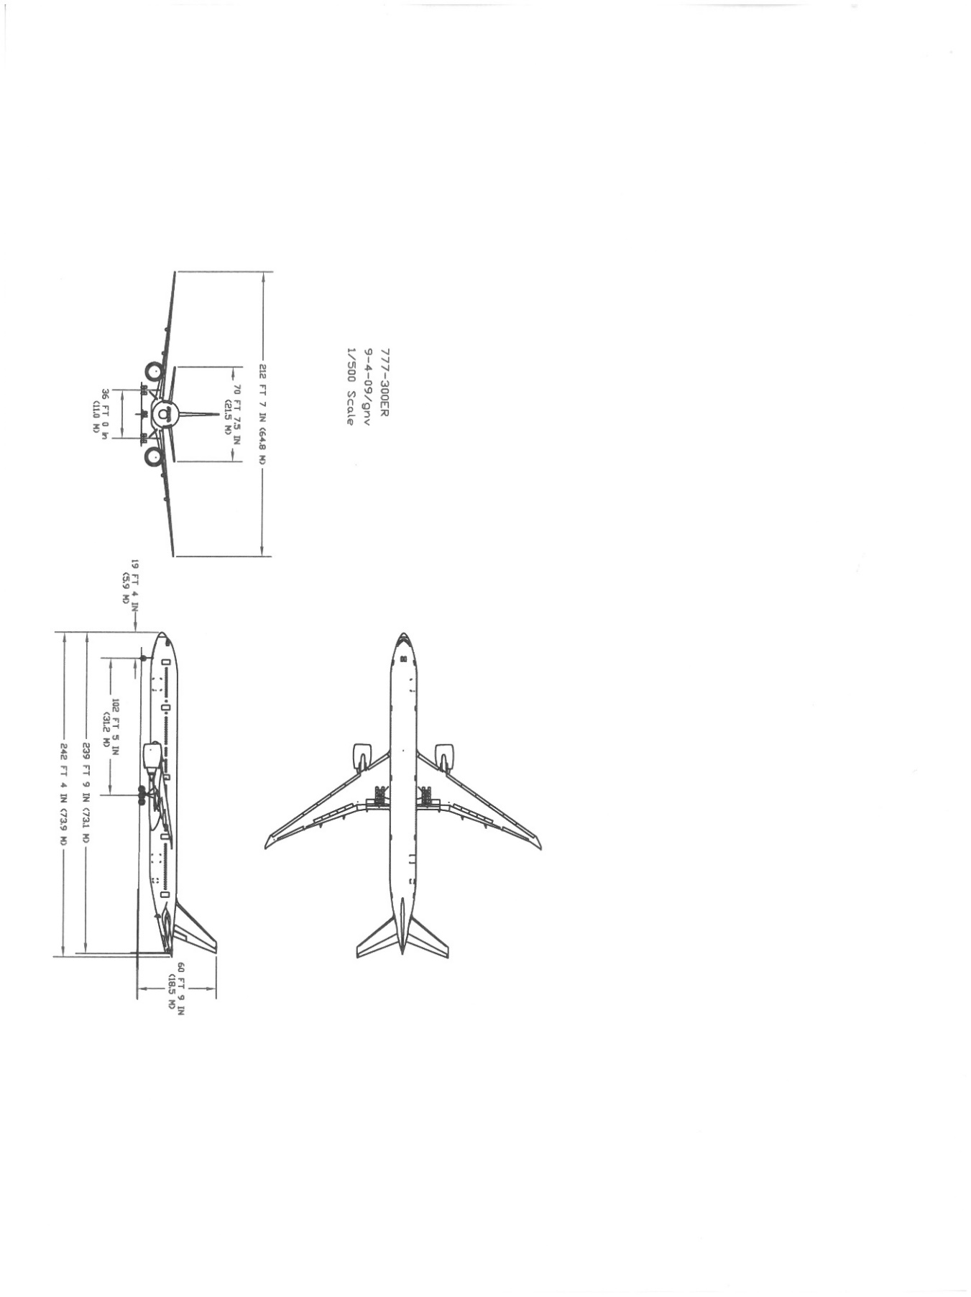

*x* (Aft)

*y* (Side)

*z* (Up)

*x* (Aft)

Figure 6 – Aircraft coordinate system

The directions of the inertia loads specified in Table 7-1 of DO-160G are defined as

|  |  |  |  |  |  |
| --- | --- | --- | --- | --- | --- |
|  | Sustained test acceleration | | | | |
| Direction of Load | Up | Down | Forward | Aft | Side |
| Load factor | 9.0 | 9.0 | 9.0 | 9.0 | 9.0 |

Table 7 – Sustained test acceleration loading

The centripetal acceleration is related to the angular velocity in revolutions per minute by the following formula as shown in Fig. 7-3 of RTCA DO-160G.

$$Acceleration \left(g^{'}s\right)=0.001118 R {\left(RPM\right)}^{2}$$

#### ATMOSPHERIC PRESSURE

Standard Ambient Conditions as described in §3.2.1.

#### TEMPERATURE

Standard Ambient Conditions as described in §3.2.2.

#### HUMIDITY

Standard Ambient Conditions as described in §3.2.3.

#### TEST EQUIPMENT

The qualification test laboratory will provide the necessary equipment in order to perform the appropriate test and a list of equipment shall be documented and provided in the report.

### TEST PROCEDURE

1. Install the test item on the centrifuge oriented in the “Up position” (bottom of the test item shall face toward center of centrifuge) per §6.5.4.1.
2. Subject the test item to the sustained acceleration level of 9G for a minimum of 3 seconds.
3. Inspect the EUT for any damage including cracked or broken glass or dislodging of the glass from its frame. Also inspect the mounting attachment points for damage and verify Pass/Fail criteria. Document any damage with photographs and/or sketches and a full description.
4. Install the test item on the centrifuge oriented in the “Down position” (reverse equipment 180 degrees from the up position) per §6.5.4.2.
5. Subject the test item to the sustained acceleration level of 9G for a minimum of 3 seconds.
6. Repeat item #3.
7. Install the test item on the centrifuge oriented in the “Side position” per §6.5.4.3.
8. Subject the test item to the sustained acceleration level of 9G for a minimum of 3 seconds.
9. Repeat item #3.
10. Install the test item on the centrifuge oriented in the “Side - Opposite position” per §6.5.4.4.
11. Subject the test item to the sustained acceleration level of 9G for a minimum of 3 seconds.
12. Repeat item #3.
13. Install the test item on the centrifuge oriented in the “Forward” per §6.5.4.5. This position has the viewing area of the test item facing toward the center of the centrifuge.
14. Subject the test item to the sustained acceleration level of 9G for a minimum of 3 seconds.
15. Repeat item #3.
16. Install the test item on the centrifuge oriented in the “Aft” per §6.5.4.6. This position has the viewing area of the test item facing away from the center of the centrifuge.
17. Subject the test item to the sustained acceleration level of 9G for a minimum of 3 seconds.
18. Repeat item #3.
19. Inspect the EUT for any damage including cracked or broken glass or dislodging of the glass from its frame. Also inspect the mounting attachment points for damage and verify Pass/Fail criteria. Document any damage with photographs and/or sketches and a full description.

### PASS/FAIL CRITERIA

The EUT shall meet the criteria identified in §7.4.

## RADIATED RF EMISSIONS

### PURPOSE OF TEST

The purpose of the Radiated RF Emissions test is to confirm that the EUT does not emit undesired RF noise exceeding the required levels.

### TEST LEVELS

The limits applied will be Category M per DO-160G (refer to Figure 21-9 in DO-160G).

### TEST SETUP

#### OPERATIONAL MODES

The EUT will remain in NORMAL OPERATIONAL MODE per §6.1.1 throughout the test.

#### EUT SETUP

The EUT shall be installed in the chamber with the appropriate cables, per §6.3.1 and §6.3.5.1. The testing shall be performed in accordance with §21.3 General Requirements and §21.5 of DO-160G. Three receive antenna positions may be needed to expose the entire EUT screen to the receive antenna. Use center and a third of the entire EUT length (excluding power and/or interconnecting cabling) from each side for the other 2 receive antenna positions. The EUT screen side will be the only orientation to be tested as it is the normal worst-case orientation for Radiated RF Emissions.

#### ATMOSPHERIC PRESSURE

Standard Ambient Conditions as described in §3.2.1.

#### TEMPERATURE

Standard Ambient Conditions as described in §3.2.2.

#### HUMIDITY

Standard Ambient Conditions as described in §3.2.3.

#### TEST EQUIPMENT

The qualification test laboratory will provide the necessary equipment in order to perform the appropriate test and a list of equipment shall be documented and provided in the report.

### TEST PROCEDURE

1. Prior to any measurements, for each antenna and polarity, measure the ambient radiated emissions levels. Record data plot of all emissions. Ambient measurements shall be made with the EUT power disconnected at the EUT’s connector (if the EUT is already placed in the chamber) and with all test support equipment turned on including the external power supplies providing AC and DC power. The ambient emission levels shall be at least 6 dB below the specified emission limit.
2. Set the EUT to NORMAL OPERATIONAL MODE per §6.1.1.
3. Take photos of the test setup, showing the monitor & antenna.
4. Measure and record the EUT emissions conditions from 100 MHz to 6 GHz, applying the limits for Category M equipment.

### PASS/FAIL CRITERIA

The EUT shall meet the criteria identified in §7.6.

## CONDUCTED RF EMISSIONS

### PURPOSE OF TEST

The purpose of the Conducted RF Emissions test is to confirm that the EUT does not emit undesired RF noise exceeding the required levels.

### TEST LEVELS

The limits applied will be Category M per DO-160G for Power Lines (refer to Figure 21-1 in DO-160G) and Interconnecting Bundles (refer to Figure 21-2 in DO-160G).

### TEST SETUP

#### OPERATIONAL MODES

The EUT will remain in NORMAL OPERATIONAL MODE per §6.1.1 throughout the test.

#### EUT SETUP

The EUT shall be installed in the chamber with the appropriate cables, per §6.3.1 and §6.3.5.2. The testing shall be performed in accordance with §21.3 General Requirements and §21.4 of DO-160G. Conducted emission measurements shall be made for each of the following, one after the other:

1. 115VAC POWER INPUT (HOT) – J1, Pin 1 line
2. 115VAC POWER RETURN (NEU) – J1, Pin 4 line
3. 28VDC POWER INPUT (+) – J1, Pin 2 line
4. 28VDC POWER RETURN (-) – J1, Pin 3 line
5. HDMI cable – J3
6. Ethernet cable – J5

#### ATMOSPHERIC PRESSURE

Standard Ambient Conditions as described in §3.2.1.

#### TEMPERATURE

Standard Ambient Conditions as described in §3.2.2.

#### HUMIDITY

Standard Ambient Conditions as described in §3.2.3.

#### TEST EQUIPMENT

The qualification test laboratory will provide the necessary equipment in order to perform the appropriate test and a list of equipment shall be documented and provided in the report.

### TEST PROCEDURE

1. Set the EUT to NORMAL OPERATIONAL MODE per §6.1.1.
2. Prepare to run conducted emissions measurements on the J1 connector cable.
3. Take photos of the test setup, showing the monitor probe for each line/cable tested.
4. Measure and record the EUT emissions applying the equipment Category M, Power Lines limit for 115VAC POWER INPUT (HOT), 115VAC POWER RETURN (NEU), 28VDC POWER INPUT (+) & 28VDC POWER RETURN (-).
5. Measure and record the EUT emissions applying the equipment Category M, Interconnecting Bundles limit for the HDMI cable and Ethernet cable.

### PASS/FAIL CRITERIA

The EUT shall meet the criteria identified in §7.6.

## ESD

### PURPOSE OF TEST

The purpose of this test will confirm immunity or the ability of equipment to perform its intended function without permanent degradation of performance as a result of an air discharged electrostatic pulse.

### TEST LEVELS

The EUT shall be subjected to a series of 10, both positive and negative voltage polarities (10 positive and 10 negative), electrostatic discharge pulses in each of the selected locations as indicated in Figure 9. The ESD generator shall have a general schematic as shown in Figure 25-2 of DO-160G, with a discharge resistor of 330 ohms (±20%) and an energy storage capacitor of 150pf (±20%) and shall be capable of generating a pulse of 15,000 volts, in both positive and negative polarities. The ESD generator shall also have an air discharge tip as shown in Figure 25-3 of DO-160G. The ESD generator shall be calibrated to produce a positive and negative 15,000 volt (+10%. -0%) peak out pulse. The generator setting required to produce this output shall be recorded.

### TEST SETUP

#### OPERATIONAL MODES

The EUT will remain in NORMAL OPERATIONAL MODE per §6.1.1 throughout the test. Temporary disturbances to video quality corresponding to the threat are not considered a failure if no permanent degradation or damage occurs. It is acceptable to take time to recover within 10 seconds.

#### EUT SETUP

The EUT shall be placed on a flat table or sturdy surface with the appropriate cables and per §6.3.1. Care must be taken in routing and grounding of the cabling associated with the ESD generator to minimize the potential for secondary effect of the radiated field from the cabling. The discharge return cable of the generator shall be grounded to the ground plane and kept at a distance of at least 0.2 meters from the EUT and its cabling

#### ATMOSPHERIC PRESSURE

Standard Ambient Conditions as described in §3.2.1.

#### TEMPERATURE

Standard Ambient Conditions as described in §3.2.2.

#### HUMIDITY

Standard Ambient Conditions as described in §3.2.3.

#### TEST EQUIPMENT

The qualification test laboratory will provide the necessary equipment in order to perform the appropriate test and a list of equipment shall be documented and provided in the report.

### TEST PROCEDURE

1. Set the EUT to NORMAL OPERATIONAL MODE per §6.1.1.
2. With the ESD generator set at the value recorded during calibration, the ESD generator shall be held perpendicular to the front surface of the EUT.
3. Move the tip of the ESD generator toward the test point at the same speed a human hand would reach to touch and object (approximately 0.3 meters/second) until the generator discharges or until contact is made with the test point.
4. After each discharge or attempted discharge, the ESD generator (discharge electrode) shall be removed from the test point.
5. Perform §7.2 – GROUP 1 PERFORMANCE MONITORING during each ESD application.
6. Repeat with reverse polarity voltage as appropriate and for each application point.

### PASS/FAIL CRITERIA

The EUT shall meet the criteria identified in §7.1 & §7.2 with the following exception:

Temporary disturbances to video quality corresponding to the threat is not considered a failure provided there is no permanent degradation or damage. It is acceptable to take time to recover within 10 seconds.



Figure 7 – ESD Application Points

## POWER INPUT

These purpose of these series of tests are performed to ensure that the equipment will perform adequately under all conditions of electrical power, as defined by DO-160G §16.

### VOLTAGE AND FREQUENCY (AC)

#### TEST LEVELS

The EUT shall operate without loss of functional performance after being exposed to the following voltage and frequency:

|  |  |  |
| --- | --- | --- |
| TEST | VOLTAGE (VRMS) | FREQUENCY (HZ) |
| 1 | 122 | 410 |
| 2 | 100 | 410 |
| 3 | 122 | 390 |
| 4 | 100 | 390 |

Table 8 – Power Input Voltage and Frequency Requirements

#### TEST SETUP

##### OPERATIONAL MODES

The EUT will remain in NORMAL OPERATIONAL MODE per §6.1.1 throughout the test.

##### EUT SETUP

The EUT shall be placed on a flat table or sturdy surface with the appropriate cables and per §6.3.1.

##### ATMOSPHERIC PRESSURE

Standard Ambient Conditions as described in §3.2.1.

##### TEMPERATURE

Standard Ambient Conditions as described in §3.2.2.

##### HUMIDITY

Standard Ambient Conditions as described in §3.2.3.

##### TEST EQUIPMENT

The qualification test laboratory will provide the necessary equipment in order to perform the appropriate test and a list of equipment shall be documented and provided in the report.

#### TEST PROCEDURE

1. Operate the EUT at maximum duty cycle for at least 30 minutes for the conditions shown in Table 5 for each test setup while monitoring the EUT per the Susceptibility Criteria.

#### PASS/FAIL CRITERIA

The EUT shall meet the criteria identified in §7.2.

### VOLTAGE MODULATION (AC)

#### TEST LEVELS

1. 115Vrms ± 1 Vrms, 400 Hz.
2. Voltage modulation will be 5.0 volts maximum peak-to-valley difference between the minimum and the maximum voltage reached on the modulation envelope applied for at least two minutes.
3. The frequency components of the voltage modulation envelope shall not exceed the limits of in Figure 9.
4. The frequency step size shall be a minimum of 4 logarithmically spaced steps per decade with additional test frequencies at each of the inflection points.

#### TEST SETUP

##### OPERATIONAL MODES

The EUT will remain in NORMAL OPERATIONAL MODE per §6.1.1 throughout the test.

##### EUT SETUP

The EUT shall be placed on a flat table or sturdy surface with the appropriate cables, per §6.3.1 and §6.3.6.1.

##### ATMOSPHERIC PRESSURE

Standard Ambient Conditions as described in §3.2.1.

##### TEMPERATURE

Standard Ambient Conditions as described in §3.2.2.

##### HUMIDITY

Standard Ambient Conditions as described in §3.2.3.

#### TEST EQUIPMENT

The qualification test laboratory will provide the necessary equipment in order to perform the appropriate test and a list of equipment shall be documented and provided in the report.

#### TEST PROCEDURE

1. Set the EUT to NORMAL OPERATIONAL MODE per §6.1.1.
2. Adjust the voltage modulation to match the minimum test levels shown in Figure 8.
3. Continually monitor the EUT per the Susceptibility Criteria during the tests.
4. Dwell for at least 2 minutes at each frequency step.

#### PASS/FAIL CRITERIA

The EUT shall meet the criteria identified in §7.2.

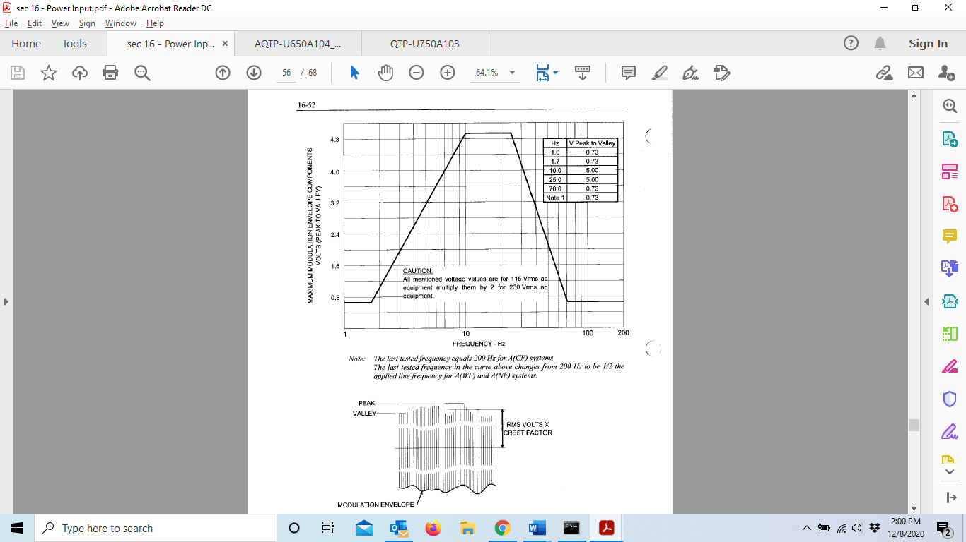

Figure 8 – Frequency Characteristics of AC Voltage Modulation Envelope

### FREQUENCY MODULATION (AC)

#### TEST LEVELS

1. 115Vrms ± 1 Vrms with a mean frequency of 400 Hz
2. The minimum set of test points shall be per the table in Figure 9.
3. If the frequency deviation is applied as discrete frequency steps instead of a sinusoidal or a triangular frequency deviation, the repetition rate dwell times shall have equal durations with ± 10% and the maximum frequency deviation step size shall be less than or equal to 2.0 Hz. For peak-to-peak ac frequency modulation less than or equal to 2.0 Hz, square wave frequency deviation is acceptable.

#### TEST SETUP

#### OPERATIONAL MODES

The EUT will remain in NORMAL OPERATIONAL MODE per §6.1.1 throughout the test.

#### EUT SETUP

The EUT shall be placed on a flat table or sturdy surface with the appropriate cables per §6.2.1.1 and §6.3.6.3.

#### ATMOSPHERIC PRESSURE

Standard Ambient Conditions as described in §3.2.1.

#### TEMPERATURE

Standard Ambient Conditions as described in §3.2.2.

#### HUMIDITY

Standard Ambient Conditions as described in §3.2.3.

#### TEST EQUIPMENT

The qualification test laboratory will provide the necessary equipment in order to perform the appropriate test and a list of equipment shall be documented and provided in the report.

#### TEST PROCEDURE

1. Set the EUT to NORMAL OPERATIONAL MODE per §6.1.1
2. Adjust the width of frequency deviation to match the minimum test levels shown in Figure 9.
3. Continually monitor the EUT per the Susceptibility Criteria during the tests.
4. Dwell for at the longer of 5 repetition rate cycles or 30 seconds.

#### PASS/FAIL CRITERIA

The EUT shall meet the criteria identified in §7.2.

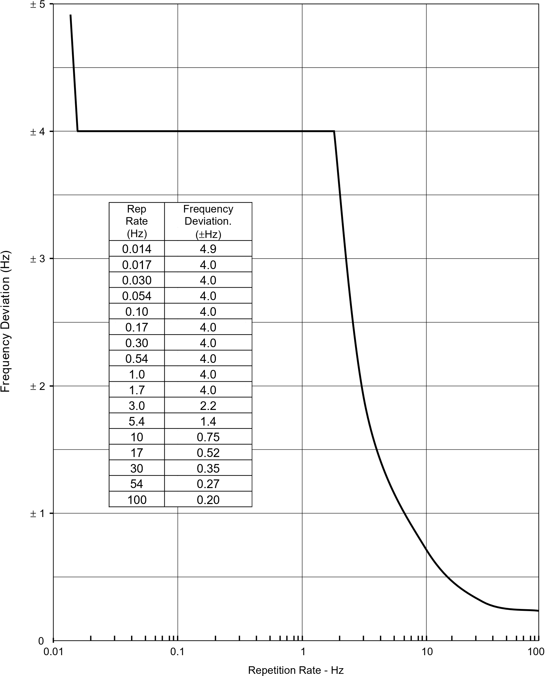

Figure 9 – Characteristics of AC Frequency Modulation

### MOMENTARY POWER INTERRUPTIONS (AC)

#### TEST LEVELS

1. 115Vrms ± 1 Vrms, 400Hz, prior to each test.
2. The EUT must meet Category A requirements. This implies that the test conditions 7, 13 and 19 are a goal and test item compliance for these conditions are not necessary.
3. A cycling of power to recover from an application is acceptable.
4. Allow at least 5 seconds for EUT power to stabilize between applications of power interrupts.

#### TEST SETUP

#### OPERATIONAL MODES

The EUT will remain in NORMAL OPERATIONAL MODE per §6.1.1 throughout the test.

#### EUT SETUP

The EUT shall be placed on a flat table or sturdy surface with the appropriate cables per §6.3.1 and §6.3.6.4.

#### ATMOSPHERIC PRESSURE

Standard Ambient Conditions as described in §3.2.1.

#### TEMPERATURE

Standard Ambient Conditions as described in §3.2.2.

#### HUMIDITY

Standard Ambient Conditions as described in §3.2.3.

#### TEST EQUIPMENT

The qualification test laboratory will provide the necessary equipment in order to perform the appropriate test and a list of equipment shall be documented and provided in the report.

#### TEST PROCEDURE

1. Prior to testing the EUT, verify and record each of the power interrupt waveforms.
2. Set the EUT to NORMAL OPERATIONAL MODE per §6.1.1.
3. Apply each of the applicable power interrupts listed in the table in Figure 10 at least twice while monitoring the EUT per the Susceptibility Criteria.

#### PASS/FAIL CRITERIA

The EUT shall meet the criteria identified in §7.2 with exceptions as described in §5.16.4.1, item 2.

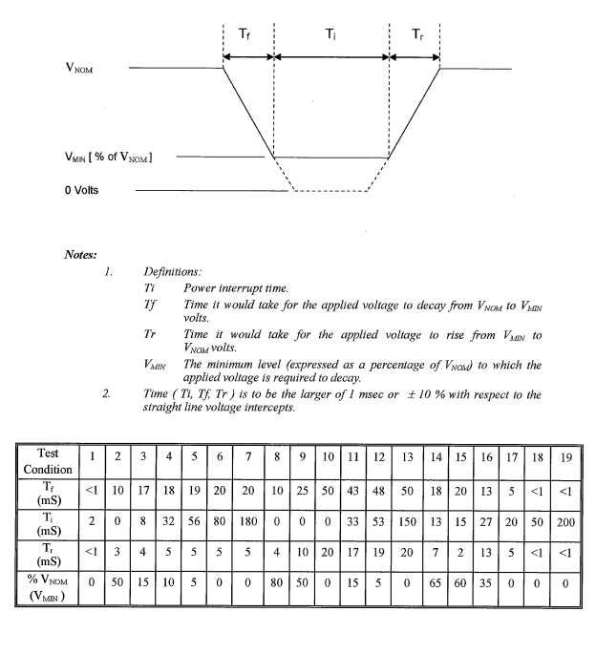

Figure 10 – Momentary Power Interruption Test Conditions for All AC Equipment

### NORMAL SURGE VOLTAGE (AC)

#### TEST LEVELS

The EUT item must meet Category A requirements as defined below:

1. 115Vrms ±5Vrms, 400Hz ±5Hz for 5 minutes
2. 160Vrms ±6Vrms, 400Hz ±5Hz for 30ms.
3. 115Vrms ±5Vrms, 400Hz ±5Hz for 5 seconds
4. 70Vrms ±3Vrms, 400Hz ±5 Hz for 30ms.
5. 115Vrms ±5Vrms, 400Hz ±5Hz for 5s (after each cycle)

#### TEST SETUP

#### OPERATIONAL MODES

The EUT will remain in NORMAL OPERATIONAL MODE per §6.1.1 throughout the test.

#### EUT SETUP

The EUT shall be placed on a flat table or sturdy surface with the appropriate cables per §6.3.1 and §6.3.6.5.

#### ATMOSPHERIC PRESSURE

Standard Ambient Conditions as described in §3.2.1.

#### TEMPERATURE

Standard Ambient Conditions as described in §3.2.2.

#### HUMIDITY

Standard Ambient Conditions as described in §3.2.3.

#### TEST EQUIPMENT

The qualification test laboratory will provide the necessary equipment in order to perform the appropriate test and a list of equipment shall be documented and provided in the report.

#### TEST PROCEDURE

1. Prior to testing the test item, verify and record each of the surge voltage waveforms
2. Set the EUT to NORMAL OPERATIONAL MODE per §6.1.1.
3. Set AC power input set at the nominal value of 115 Vrms ±5V rms, 400 Hz ±5Hz for 5 minutes
4. Increase the power supply voltage to 160Vrms ±6V rms, 400Hz for 30ms
5. Return the power supply voltage to 115Vrms ±5Vrms, 400Hz ±5Hz for 5 seconds
6. Decrease the power supply voltage to 70Vrms ±3Vrms, 400Hz ±5 Hz for 30ms.
7. Return the power supply voltage to 115Vrms, 400 Hz for 5sec.
8. Perform the sequence steps 4 - 7 above three times.

#### PASS/FAIL CRITERIA

The EUT shall meet the criteria identified in §7.2.

### NORMAL FREQUENCY TRANSIENTS (AC)

#### TEST LEVELS

1. Initial condition: 115Vrm s± 1 Vrms, 400Hz
2. 440Hz ± 5Hz for 150 ms
3. 420 Hz for 1.5 seconds
4. 400 Hz for 5 seconds
5. 350 Hz ± 5 Hz for 150 ms
6. 380 Hz for 1.5 seconds
7. 400 Hz for 5 seconds

#### TEST SETUP

#### OPERATIONAL MODES

The EUT will remain in NORMAL OPERATIONAL MODE per §6.1.1 throughout the test.

#### EUT SETUP

The EUT shall be placed on a flat table or sturdy surface with the appropriate cables per §6.3.1 and §6.3.6.6.

#### ATMOSPHERIC PRESSURE

Standard Ambient Conditions as described in §3.2.1.

#### TEMPERATURE

Standard Ambient Conditions as described in §3.2.2.

#### HUMIDITY

Standard Ambient Conditions as described in §3.2.3.

#### TEST EQUIPMENT

The qualification test laboratory will provide the necessary equipment in order to perform the appropriate test and a list of equipment shall be documented and provided in the report.

#### TEST PROCEDURE

1. Set the EUT to NORMAL OPERATIONAL MODE per §6.1.1.
2. Set the AC power input at the nominal value of 115 Vrms, 400 Hz for 5 minutes
3. Increase the frequency to 440 Hz for 150ms
4. Decrease the frequency to 420 Hz for 1.5 seconds
5. Return the frequency to 400 Hz for 5 seconds
6. Decrease the frequency to 350 Hz for 150 ms
7. Increase the frequency to 380 Hz for 1.5 seconds
8. Return the frequency to 400 Hz for 5 seconds
9. Perform the sequence of steps 3 - 8 three times
10. Monitor the EUT per the Susceptibility Criteria

#### PASS/FAIL CRITERIA

The EUT shall meet the criteria identified in §7.2.

### VOLTAGE DC CONTENT (AC)

#### TEST LEVELS

1. DC offset: -0.200 +0/-0.04V and +0.200 +0.040/-0V
2. Frequency: 400Hz

#### TEST SETUP

#### OPERATIONAL MODES

The EUT will remain in NORMAL OPERATIONAL MODE per §6.1.1 throughout the test.

#### EUT SETUP

The EUT shall be placed on a flat table or sturdy surface with the appropriate cables per §6.3.1 and §6.3.6.7.

#### ATMOSPHERIC PRESSURE

Standard Ambient Conditions as described in §3.2.1.

#### TEMPERATURE

Standard Ambient Conditions as described in §3.2.2.

#### HUMIDITY

Standard Ambient Conditions as described in §3.2.3.

#### TEST EQUIPMENT

The qualification test laboratory will provide the necessary equipment in order to perform the appropriate test and a list of equipment shall be documented and provided in the report.

#### TEST PROCEDURE

1. Set the AC power input at the nominal value of 115 Vrms, 400 Hz.
2. Set the EUT to NORMAL OPERATIONAL MODE per §6.1.1.
3. Apply a voltage dc offset of -0.200 +0/-0.04V to each of the AC power input leads for 30 minutes while monitoring the EUT for susceptibility.
4. Apply a voltage dc offset of +0.200 +0.040/-0V to each of the AC power input leads for 30 minutes while monitoring the EUT per the Susceptibility Criteria

#### PASS/FAIL CRITERIA

The EUT shall meet the criteria identified in §7.2.

### VOLTAGE DISTORTION (AC)

#### TEST LEVELS

1. AC power input at the value of 100 Vrms, 390 Hz
2. Voltage total distortion level: 8 % +2/-0 %
3. The voltage distortion may be produced via a full-wave rectifier bridge as shown in §6.3.6.8.
4. The level of voltage distortion can be controlled by varying the load on the rectifier(s) and insertion of source impedance in the line. Alternatively, input voltage to the EUT may be distorted by clipping the supply voltage.

#### TEST SETUP

#### OPERATIONAL MODES

The EUT will remain in NORMAL OPERATIONAL MODE per §6.1.1 throughout the test.

#### EUT SETUP

The EUT shall be placed on a flat table or sturdy surface with the appropriate cables, per §6.3.1 and §6.3.6.8 (if this method used).

#### ATMOSPHERIC PRESSURE

Standard Ambient Conditions as described in §3.2.1.

#### TEMPERATURE

Standard Ambient Conditions as described in §3.2.2.

#### HUMIDITY

Standard Ambient Conditions as described in §3.2.3.

#### TEST EQUIPMENT

The qualification test laboratory will provide the necessary equipment in order to perform the appropriate test and a list of equipment shall be documented and provided in the report.

#### TEST PROCEDURE

1. Set the EUT to NORMAL OPERATIONAL MODE per §6.1.1.
2. Set the AC power input at the value of 100 Vrms, 390 Hz
3. Apply a voltage total distortion level of 8 % +2/-0 % at the AC power input leads for 30 minutes while monitoring the EUT per the Susceptibility Criteria.

#### PASS/FAIL CRITERIA

The EUT shall meet the criteria identified in §7.2.

### ABNORMAL VOLTAGE AND FREQUENCY LIMITS IN STEADY STATE (AC)

#### TEST LEVELS

The EUT shall operate without loss of functional performance after being exposed to each of the following voltages and frequencies for 5 minutes:

|  |  |  |
| --- | --- | --- |
| TEST | VOLTAGE (VRMS) | FREQUENCY (HZ) |
| 1 | 134 | 400 |
| 2 | 97 | 400 |
| 3 | 122 | 430 |
| 4 | 100 | 430 |
| 5 | 122 | 370 |
| 6 | 100 | 370 |

Table 9 – Abnormal Power Input AC Test Requirements

#### TEST SETUP

#### OPERATIONAL MODES

The EUT will remain in NORMAL OPERATIONAL MODE per §6.1.1 throughout the test.

#### EUT SETUP

The EUT shall be placed on a flat table or sturdy surface with the appropriate cables, per §6.3.1 and §6.3.6.9.

#### ATMOSPHERIC PRESSURE

Standard Ambient Conditions as described in §3.2.1.

#### TEMPERATURE

Standard Ambient Conditions as described in §3.2.2.

#### HUMIDITY

Standard Ambient Conditions as described in §3.2.3.

#### TEST EQUIPMENT

The qualification test laboratory will provide the necessary equipment in order to perform the appropriate test and a list of equipment shall be documented and provided in the report.

#### TEST PROCEDURE

1. Set the EUT to NORMAL OPERATIONAL MODE per §6.1.1.
2. Apply test conditions 1 and 2 each from Table 9 for 30 minutes.
3. Set the AC power input at the nominal value of 115 Vrms, 400 Hz between each test condition above and complete §7.1 – GROUP 1 PERFORMANCE TESTS and record the results.
4. Apply test conditions 3-6 from Table 9 for 30 minutes while monitoring the EUT per the Susceptibility Criteria.

#### PASS/FAIL CRITERIA

The EUT shall meet the criteria identified in §7.1 & §7.2.

### MOMENTARY UNDERVOLTAGE OPERATION (AC)

#### TEST LEVELS

The EUT shall operate normally when returned to normal operating voltage after exposure to the following voltage and frequency:

|  |  |  |  |
| --- | --- | --- | --- |
| TEST | VOLTAGE (VRMS) | TIME (SECONDS) | FREQUENCY (HZ) |
| 1 | 60 | 7 | 400 |
| 2 | 10 | 7 | 400 |

Table 10 – Momentary Undervoltage Operation Requirements

#### TEST SETUP

#### OPERATIONAL MODES

The EUT will remain in NORMAL OPERATIONAL MODE per §6.1.1 throughout the test. It is acceptable for the EUT to shut off or display degradation of performance while in the undervoltage condition provided the ETU recovers after each test condition.

#### EUT SETUP

The EUT shall be placed on a flat table or sturdy surface with the appropriate cables, per §6.3.1 and § 6.5.6.10.

#### ATMOSPHERIC PRESSURE

Standard Ambient Conditions as described in §3.2.1.

#### TEMPERATURE

Standard Ambient Conditions as described in §3.2.2.

#### HUMIDITY

Standard Ambient Conditions as described in §3.2.3.

#### TEST EQUIPMENT

The qualification test laboratory will provide the necessary equipment in order to perform the appropriate test and a list of equipment shall be documented and provided in the report.

#### TEST PROCEDURE

1. Set the AC power input at the nominal value of 115 Vrms, 400 Hz.
2. Set the EUT to NORMAL OPERATIONAL MODE per §6.1.1.
3. Apply test conditions 1 and 2 each from Table 10.
4. Set the AC power input at the nominal value of 115 Vrms, 400 Hz between each test condition above and complete §7.1 – GROUP 1 PERFORMANCE TESTS and record the results.

#### PASS/FAIL CRITERIA

The EUT shall meet the criteria identified in §7.1.

### ABNORMAL SURGE VOLTAGE (AC)

#### TEST LEVELS

1. Initial condition: 115Vrms, 400Hz
2. 180 Vrms for 100ms
3. 148 Vrms for 1 second
4. Voltage change from 180 Vrms to 148 shall be done within 1ms

#### TEST SETUP

#### OPERATIONAL MODES

The EUT will remain in NORMAL OPERATIONAL MODE per §6.1.1 throughout the test.

#### EUT SETUP

The EUT shall be placed on a flat table or sturdy surface with the appropriate cables, per §6.3.1 and §6.3.6.10.

#### ATMOSPHERIC PRESSURE

Standard Ambient Conditions as described in §3.2.1.

#### TEMPERATURE

Standard Ambient Conditions as described in §3.2.2.

#### HUMIDITY

Standard Ambient Conditions as described in §3.2.3.

#### TEST EQUIPMENT

The qualification test laboratory will provide the necessary equipment in order to perform the appropriate test and a list of equipment shall be documented and provided in the report.

#### TEST PROCEDURE

1. Prior to testing the EUT, verify and record each of the surge voltage waveforms.
2. The voltage change from one level to another for 1 cycle (# 5 - #8) should be done within 1ms.
3. Verify that the proper waveform parameters and record the waveform
4. Set the AC power input at the nominal value of 115 Vrms, 400 Hz
5. Set the EUT to NORMAL OPERATIONAL MODE per §6.1.1.
6. Apply a voltage surge of 180 Vrms for 100ms.
7. Reduce the voltage to 148 Vrms for 1 second.
8. Return AC power to the nominal value of 115 Vrms, 400 Hz.
9. Apply the surge voltage 3 times at 10-second intervals between tests.
10. Monitor the EUT for susceptibility per the Susceptibility Criteria throughout the tests.

#### PASS/FAIL CRITERIA

The EUT shall meet the criteria identified in §7.2.

### ABNORMAL FREQUENCY TRANSIENTS (AC)

#### TEST LEVELS

TEST 1

1. Initial condition: 115Vrms, 400Hz
2. 350 Hz ± 5 Hz for 5 seconds
3. 320 Hz ± 5 Hz for 200 ms.
4. 0 Vrms for 200 ms -0/+20 ms
5. 115Vrms, 400Hz for 10 seconds

TEST 2

1. Initial condition: 115Vrms, 400Hz
2. 480 Hz ± 5 Hz for 200 ms
3. 440 Hz ± 5 Hz for 5 seconds
4. 0 Vrms and frequency 400 Hz for 200 ms -0/+20 ms
5. 115Vrms, 400Hz for 10 seconds

#### TEST SETUP

#### OPERATIONAL MODES

The EUT will remain in NORMAL OPERATIONAL MODE per §6.1.1 throughout the test. Degradation of performance is acceptable provided the EUT recovers after power cycle.

#### EUT SETUP

The EUT shall be placed on a flat table or sturdy surface with the appropriate cables and per §6.3.1.

#### ATMOSPHERIC PRESSURE

Standard Ambient Conditions as described in §3.2.1.

#### TEMPERATURE

Standard Ambient Conditions as described in §3.2.2.

#### HUMIDITY

Standard Ambient Conditions as described in §3.2.3.

#### TEST EQUIPMENT

The qualification test laboratory will provide the necessary equipment in order to perform the appropriate test and a list of equipment shall be documented and provided in the report.

#### TEST PROCEDURE

1. Test 1 Start - Set the AC power input at the nominal value of 115 Vrms, 400 Hz
2. Set the EUT to NORMAL OPERATIONAL MODE per §6.1.1 and operate for at least 5 minutes
3. Decrease the frequency to 350 Hz ± 5 Hz in less than 1 ms and operate the EUT for 5 seconds
4. Decrease the frequency to 320 Hz ± 5 Hz in less than 1 ms and operate the EUT for 200 ms
5. Decrease the voltage to 0 Vrms and maintain at 0 Vrms for 200 -0/+20 ms
6. Return AC power to the nominal value of 115 Vrms, 400 Hz in less than 1 ms and operate the EUT for 10 seconds
7. Apply sequence of steps 3 – 6, 2 more times at 10-second intervals between tests
8. Monitor the EUT for susceptibility per the Susceptibility Criteria throughout the tests
9. Test 2 Start - Set the AC power input at the nominal value of 115 Vrms, 400 Hz
10. Set the EUT to NORMAL OPERATIONAL MODE per §6.1.1 and operate for at least 5 minutes
11. Increase the frequency to 480 Hz ± 5 Hz and operate the EUT for 200ms seconds
12. Decrease the frequency to 440 Hz ± 5 Hz in less than 1 ms and operate the EUT for 5 seconds
13. Decrease the voltage to 0 Vrms and the frequency to 400 Hz in less than 1 ms and maintain at 0 Vrms for 200 -0/+20 ms.
14. Return AC power to the nominal value of 115 Vrms, 400 Hz in less than 1 ms and operate the EUT for 10 seconds
15. Apply sequence of steps 11 – 14, 2 more times at 10-second intervals between tests
16. Monitor the EUT for susceptibility per the Susceptibility Criteria throughout the tests

#### PASS/FAIL CRITERIA

The EUT shall meet the criteria identified in §7.1.

Note: Degradation of performance is acceptable provided the EUT recovers after power cycle.

### DC CURRENT CONTENT IN STEADY-STATE OPERATION (AC)

#### TEST LEVELS

1. These tests shall be performed with a frequency of 400 Hz with a power source with a voltage of 115 Vrms, with a dc component of 0.00 ± 10 Vdc at its terminals.
2. If the difference between maximum and minimum steady state current is less than 25% of the maximum steady state current, only the maximum steady state current operating mode needs to be tested.

#### TEST SETUP

#### OPERATIONAL MODES

The EUT will remain in NORMAL OPERATIONAL MODE per §6.1.1 throughout the test.

#### EUT SETUP

The EUT shall be placed on a flat table or sturdy surface with the appropriate cables and per §6.3.1.

#### ATMOSPHERIC PRESSURE

Standard Ambient Conditions as described in §3.2.1.

#### TEMPERATURE

Standard Ambient Conditions as described in §3.2.2.

#### HUMIDITY

Standard Ambient Conditions as described in §3.2.3.

#### TEST EQUIPMENT

The qualification test laboratory will provide the necessary equipment in order to perform the appropriate test and a list of equipment shall be documented and provided in the report.

#### TEST PROCEDURE

1. Operate the EUT in the mode that draws maximum stead-state current.
2. After stabilizing the equipment, measure the DC content of the EUT line current.
3. Operate the EUT in the mode that draws minimum stead-state current.
4. After stabilizing the equipment, measure the DC content of the EUT line current.
5. Decrease the voltage to 0 Vrms and the frequency to 400 Hz in less than 1 ms and maintain at 0 Vrms for 200 -0/+20 ms.
6. Return AC power to the nominal value of 115 Vrms, 400 Hz in less than 1 ms and operate the EUT for 10 seconds.
7. Apply sequence of steps 11 – 14, 2 more times at 10-second intervals between tests.
8. Monitor the EUT for susceptibility per the Susceptibility Criteria throughout the tests.

#### PASS/FAIL CRITERIA

The DC component shall not exceed the higher of 5 mA or 2% of the maximum RMS value of the EUT.

## VOLTAGE SPIKE

### PURPOSE OF TEST

The purpose of this test will confirm that the EUT is able to withstand the effects of voltage spikes arriving at the equipment on its power leads, either AC or DC, per DO-160G §17.0 requirements.

### TEST LEVELS

Voltage spikes of 600V will be applied to the power input lines.

### TEST SETUP

#### OPERATIONAL MODES

The EUT will remain in NORMAL OPERATIONAL MODE per §6.1.1 throughout the test.

#### EUT SETUP

The EUT shall be placed on a flat table or sturdy surface with the appropriate cables and per §6.3.1.

#### ATMOSPHERIC PRESSURE

Standard Ambient Conditions as described in §3.2.1.

#### TEMPERATURE

Standard Ambient Conditions as described in §3.2.2.

#### HUMIDITY

Standard Ambient Conditions as described in §3.2.3.

#### TEST EQUIPMENT

The qualification test laboratory will provide the necessary equipment in order to perform the appropriate test and a list of equipment shall be documented and provided in the report.

### TEST PROCEDURE

1. Prior to any testing, the generator impedance shall be verified to be 50Ω±10%.
2. With generator output level set to produce the required test voltage across an open circuit, place a 50Ω resister across the output of the generator. Verify that the output level is reduced by 50%±10% and record the waveform.
3. Adjust the spike generator to produce a positive polarity pulse at the required test level across an open circuit.
4. Verify that the proper waveform parameters as shown in Figure 11 and record the waveform.
5. Set the EUT to NORMAL OPERATIONAL MODE per §6.1.1.
6. Take photos of the test setup.
7. Subject the selected power line to 50 positive polarity spikes within a 60 second period.
8. Perform §7.2 – GROUP 1 PERFORMANCE MONITORING during step 7, record the results.
9. Repeat step 7 with the same spikes in negative polarity.
10. Complete §7.1 – GROUP 1 PERFORMANCE TESTS and record the results.

### PASS/FAIL CRITERIA

The EUT shall meet the criteria identified in §7.1 & §7.2.



Figure 11 – Voltage Spike Waveform

## AUDIO FREQUENCY CONDUCTED SUSCEPTIBILITY

### PURPOSE OF TEST

This test determines whether the equipment will accept frequency components of a magnitude normally expected when installed in an aircraft.

### TEST LEVELS

See Figure 12 for test levels per frequency.

The EUT shall operate without loss of functional performance when subjected to the required levels for AF conducted susceptibility test levels under the conditions listed in the following table.:

|  |  |  |  |
| --- | --- | --- | --- |
| LINE UNDER TEST | | TEST FREQUENCY | CATEGORY |
| VOLTAGE | FREQUENCY |
| 115 V | 400 +5/-0Hz | 700Hz to 16KHz | R(CF) |

Table 11 – AF Conducted Susceptibility Requirements

Frequency Scan Rates

For test equipment that generate discrete frequencies, the minimum number of test frequencies shall be 30 frequencies per decade. The test frequencies shall be logarithmically spaced. As an example, a formula that can be used to calculate these frequencies for 30 steps per decade in ascending order is:

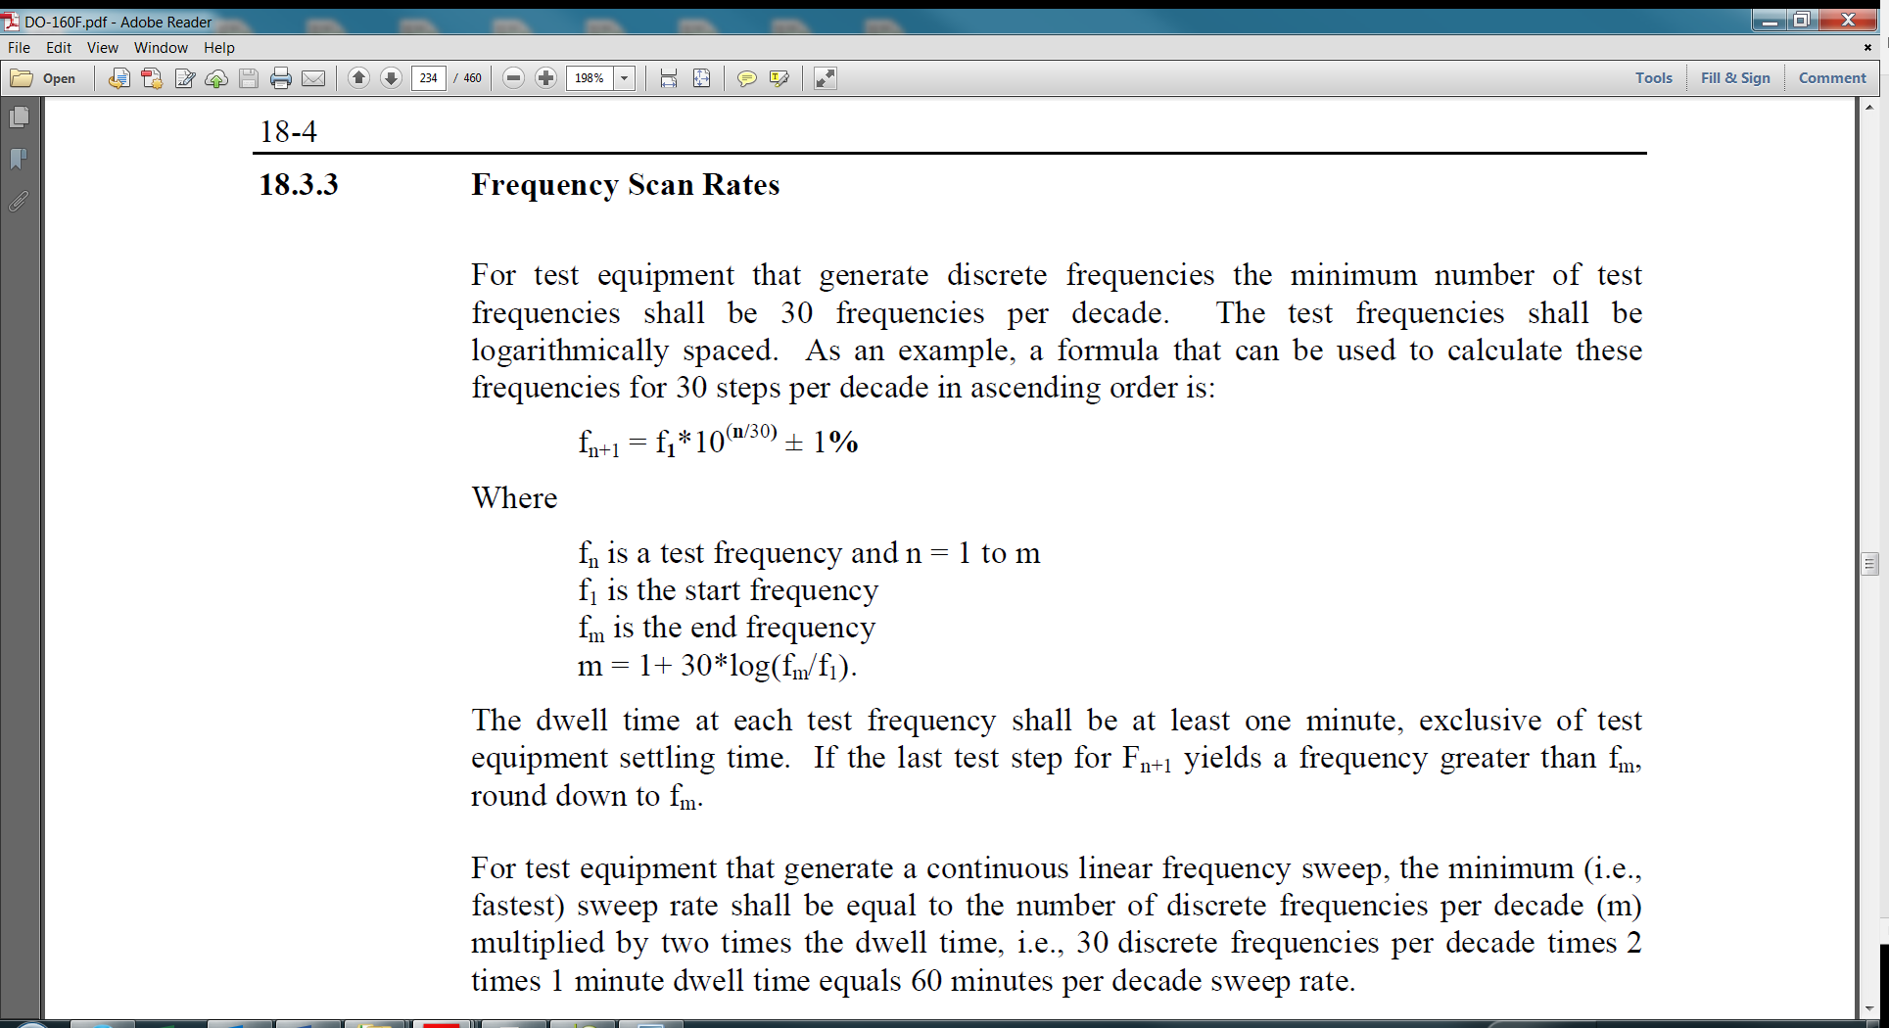

For test equipment that generate a continuous frequency sweep, the minimum (i.e., fastest) sweep rate shall be equal to the number of discrete frequencies per decade (m) multiplied by the dwell time (i.e., 30 discrete frequencies per decade times 2-minute dwell time equals 60 minutes per decade sweep rate).

### TEST SETUP

#### OPERATIONAL MODES

The EUT will remain in NORMAL OPERATIONAL MODE per §6.1.1 throughout the test.

#### EUT SETUP

The EUT shall be placed on a flat table or sturdy surface with the appropriate cables and per §6.2.1.1.

#### ATMOSPHERIC PRESSURE

Standard Ambient Conditions as described in §3.2.1.

#### TEMPERATURE

Standard Ambient Conditions as described in §3.2.2.

#### HUMIDITY

Standard Ambient Conditions as described in §3.2.3.

#### TEST EQUIPMENT

The qualification test laboratory will provide the necessary equipment in order to perform the appropriate test and a list of equipment shall be documented and provided in the report.

### TEST PROCEDURE

1. Set the EUT to NORMAL OPERATIONAL MODE per §6.1.1.
2. Take photos of the test setup.
3. Apply a sine wave audio frequency signal successively in series with each unground AC input power lead, while varying the frequency of the applied signal between 700 Hz and 16 kHz.
4. Perform §7.2 – GROUP 1 PERFORMANCE MONITORING during step 7, record the results.
5. Complete §7.1 – GROUP 1 PERFORMANCE TESTS and record the results.

### PASS/FAIL CRITERIA

The EUT shall meet the criteria identified in §7.1 & §7.2.

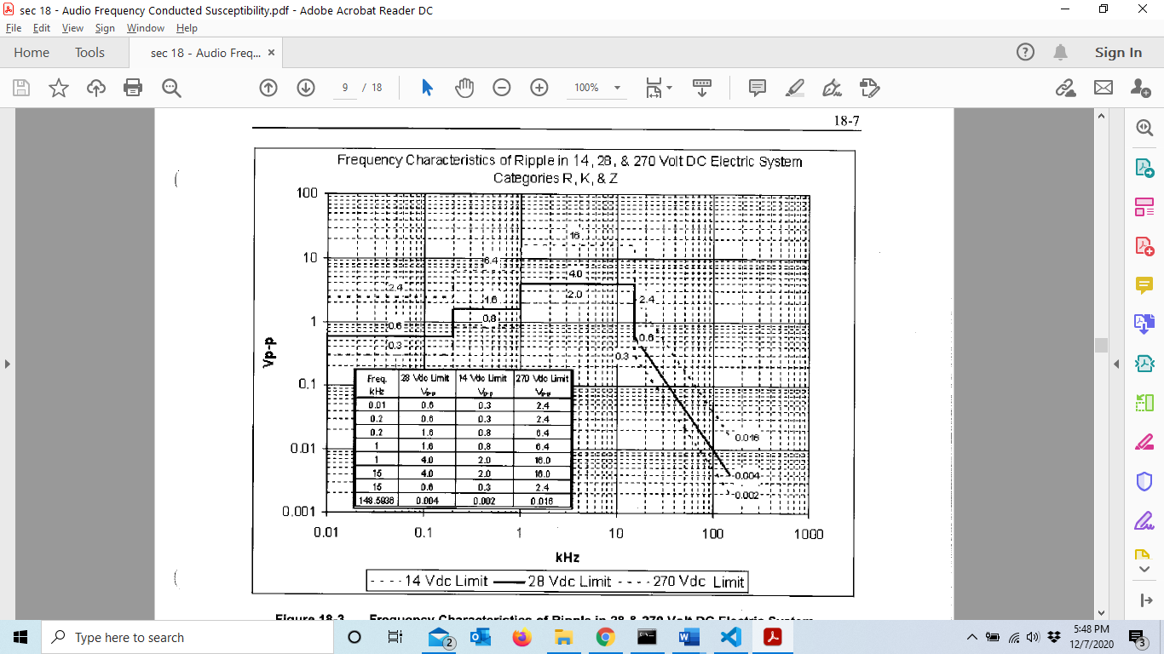

Figure 12 – AF Conducted Susceptibility Limits

## INDUCED SIGNAL SUSCEPTIBILITY

Induced Signal Susceptibility tests determine whether the equipment interconnect circuit configuration will accept a level of induced voltages caused by the installation environment. Power leads tested under Audio Frequency Conducted Susceptibility are exempt from this test.

### MAGNETIC FIELDS INDUCED INTO EQUIPMENT

#### TEST LEVELS

The equipment shall operate without loss of functional performance when subjected to magnetic fields produced by a current of 20 A rms at 400 Hz flowing through a straight wire.

The wire segment shall be located within 15 cm moving parallel to the surface of the EUT. The length of the segment shall be as such that it extends at least 0.6 m (laterally) past each extremity of the EUT. The leads supplying current to the segment shall be routed at least 0.6 m from any portion of the EUT and from that portion of the segment directly opposite the EUT. All sides of the test sample are thoroughly probed for susceptibility.

Primary power is variable over a narrow frequency range of 350 Hz – 650 Hz.

Testing shall be performed in accordance with DO-160G, Category CN.

#### TEST SETUP

##### OPERATIONAL MODES

The EUT will remain in NORMAL OPERATIONAL MODE per §6.1.1 throughout the test.

##### EUT SETUP

The EUT shall be placed on a flat table or sturdy surface with the appropriate cables, per §6.3.1 and §6.3.9.1.

##### ATMOSPHERIC PRESSURE

Standard Ambient Conditions as described in §3.2.1.

##### TEMPERATURE

Standard Ambient Conditions as described in §3.2.2.

##### HUMIDITY

Standard Ambient Conditions as described in §3.2.3.

##### TEST EQUIPMENT

The qualification test laboratory will provide the necessary equipment in order to perform the appropriate test and a list of equipment shall be documented and provided in the report.

### TEST PROCEDURE

1. Set the EUT to NORMAL OPERATIONAL MODE per §6.1.1.
2. Subject the front face of the EUT to the required induced magnetic field test level
3. Perform §7.2 – GROUP 1 PERFORMANCE MONITORING during step 2, record the results.
4. Repeat test for Rear, Left, Right, Top and Bottom faces of the EUT
5. Perform §7.2 – GROUP 1 PERFORMANCE MONITORING during for each face in item # 4, record the results.

### PASS/FAIL CRITERIA

The EUT shall meet the criteria identified in §7.2.

### MAGNETIC FIELDS INDUCED INTO INTERCONNECTING CABLES

#### TEST LEVELS

The equipment shall operate without loss of functional performance when interconnecting cables are subjected to magnetic fields at DO-160G, Category CN test levels. The test levels are defined in Figure 19-1(b) of DO-160G.

The leads applying voltage to the radiator shall be routed at least 0.6 m away from any part of the unit under test and from the radiator itself. The electric field power source shall not be synchronized with the power source of the equipment supply.

Testing shall be performed in accordance with DO-160G, Category CN.

#### TEST SETUP

##### OPERATIONAL MODES

The EUT will remain in NORMAL OPERATIONAL MODE per §6.1.1 throughout the test.

##### EUT SETUP

The EUT shall be placed on a flat table or sturdy surface with the appropriate cables, per §6.3.1 and §6.3.9.2.

##### ATMOSPHERIC PRESSURE

Standard Ambient Conditions as described in §3.2.1.

##### TEMPERATURE

Standard Ambient Conditions as described in §3.2.2.

##### HUMIDITY

Standard Ambient Conditions as described in §3.2.3.

##### TEST EQUIPMENT

The qualification test laboratory will provide the necessary equipment in order to perform the appropriate test and a list of equipment shall be documented and provided in the report.

#### TEST PROCEDURE

1. Set the EUT to NORMAL OPERATIONAL MODE per §6.1.1.
2. Subject the EUT to the required induced magnetic field test level
3. Perform §7.2 – GROUP 1 PERFORMANCE MONITORING during step 2, record the results.

#### PASS/FAIL CRITERIA

The EUT shall meet the criteria identified in §7.2.

### ELECTRIC FIELDS INDUCED INTO INTERCONNECTING CABLES

#### TEST LEVELS

The equipment shall operate without loss of functional performance when interconnecting cables are subjected to electric fields at DO-160G, Category CN test levels. The test levels are defined in Figure 19-1(e) of DO-160G.

Spiral wrapping of the radiator wire around the cable under test is required. The electric field power source shall not be synchronized with the power source of the equipment supply.

Testing shall be performed in accordance with DO-160G, Category CN.

#### TEST SETUP

##### OPERATIONAL MODES

The EUT will remain in NORMAL OPERATIONAL MODE per §6.1.1 throughout the test.

##### EUT SETUP

The EUT shall be placed on a flat table or sturdy surface with the appropriate cables, per §6.3.1 and §6.3.9.3.

##### ATMOSPHERIC PRESSURE

Standard Ambient Conditions as described in §3.2.1.

##### TEMPERATURE

Standard Ambient Conditions as described in §3.2.2.

##### HUMIDITY

Standard Ambient Conditions as described in §3.2.3.

##### TEST EQUIPMENT

The qualification test laboratory will provide the necessary equipment in order to perform the appropriate test and a list of equipment shall be documented and provided in the report.

#### TEST PROCEDURE

1. Set the EUT to NORMAL OPERATIONAL MODE per §6.1.1.
2. Subject the interconnecting cables to the required electric field test levels.
3. Perform §7.2 – GROUP 1 PERFORMANCE MONITORING during step 2, record the results.

#### PASS/FAIL CRITERIA

The EUT shall meet the criteria identified in §7.2.

### SPIKES INDUCED INTO INTECONNECTING CABLES

#### TEST LEVELS

Positive and negative polarity spikes at no less than 600V peak-to-peak.

The rate of the spikes shall be 8 to 10 transients per second for a duration of not less than 2 minutes for each polarity. Ensure that there are 3 spirals per meter for 3 meters Length (L) per §6.3.9.4. For each test configuration, point A shall be monitored to verify that the specified peak-to-peak voltage is developed (with respect to ground) during performance of the test.

#### TEST SETUP

##### OPERATIONAL MODES

The EUT will remain in NORMAL OPERATIONAL MODE per §6.1.1 throughout the test. Degradation of performance or loss of video is acceptable when the threat is applied provided it recovers after the threat is removed.

##### EUT SETUP

The EUT shall be placed on a flat table or sturdy surface with the appropriate cables, per §6.3.1 and §6.3.9.4.

##### ATMOSPHERIC PRESSURE

Standard Ambient Conditions as described in §3.2.1.

##### TEMPERATURE

Standard Ambient Conditions as described in §3.2.2.

##### HUMIDITY

Standard Ambient Conditions as described in §3.2.3.

##### TEST EQUIPMENT

The qualification test laboratory will provide the necessary equipment in order to perform the appropriate test and a list of equipment shall be documented and provided in the report.

#### TEST PROCEDURE

1. Set the EUT to NORMAL OPERATIONAL MODE per §6.1.1.
2. Subject the HDMI cable to the to the required test levels per Figure 13.
3. Perform §7.2 – GROUP 1 PERFORMANCE MONITORING during step 2, record the results.
4. Apply both positive and negative polarity tests.
5. Repeat the tests subjecting the Ethernet cable to the required test levels for both positive and negative polarities.
6. Complete §7.1 – GROUP 1 PERFORMANCE TESTS and record the results.

#### PASS/FAIL CRITERIA

The EUT shall meet the criteria identified in §7.1 .

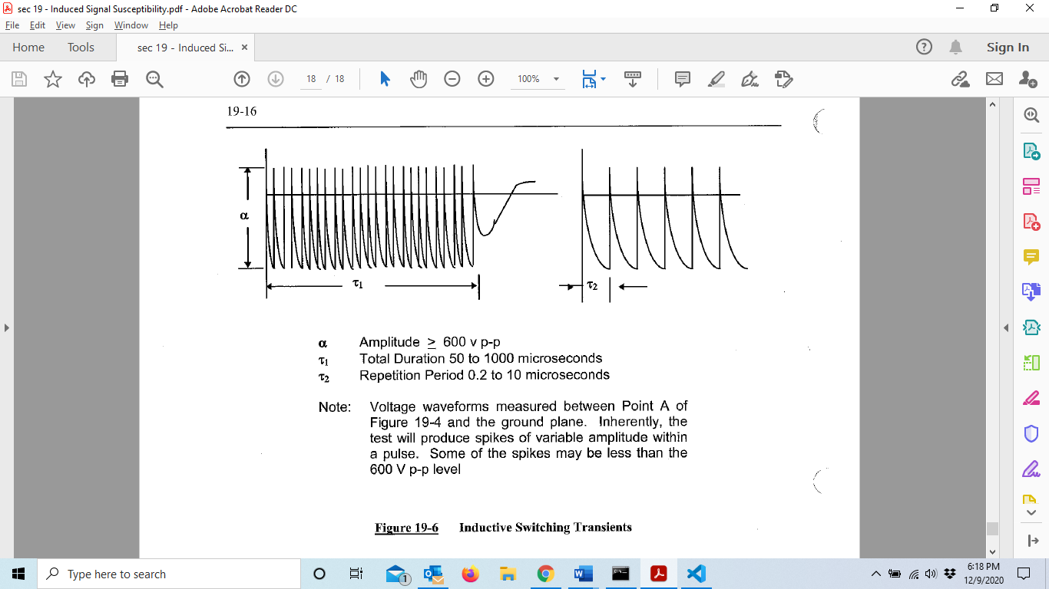

Note: Voltage waveforms measured between Point A of Figure 51 and the ground plane.

Figure 13 – Inductive Switching Transients

## RADIATED RF SUSCEPTIBILITY

### PURPOSE OF TEST

Radiated RF Susceptibility tests determine whether the EUT will operate without loss of functional performance when the EUT and its interconnecting wiring are exposed to a level of RF modulated power by a radiated RF field.

### TEST LEVELS

The test levels shall be 5 V/m for Square Wave (SW) and Continuous Wave (CW) modulation.

The testing shall be performed in accordance with §20.3 General Requirements and §20.5 of DO-160G. Frequencies tested will be 100 MHz to 8 GHz. From 100 MHz to 8 GHz, use CW as well as 1 kHz square wave modulation with at least 90% depth.

Step Rate/Dwell Time:

|  |  |  |
| --- | --- | --- |
| FREQUENCY RANGE | STEP RATE | DWELL TIME |
| 100 MHz to 200 MHz | 100 steps/decade | 1 second |

Table 12 – RF Susceptibility Step Rate/Dwell Time

Dwell Frequencies:

|  |  |
| --- | --- |
| DWELL FREQUENCY | FREQUENCY SOURCE |
| *[125 MHz]* | *[Ethernet]* |
| *[148.5 MHz]* | *[HDMI Pixel Clock]* |
| *[74.25 MHz]* | *[LCD DCLK]* |

Table 13 – RF Susceptibility Dwell Frequencies

### TEST SETUP

#### OPERATIONAL MODES

The EUT will remain in NORMAL OPERATIONAL MODE per §6.1.1 throughout the test.

#### EUT SETUP

The EUT shall be installed in the chamber with the appropriate cables, per §6.2.2 and §6.3.10.1.

The EUT screen side will be the only orientation to be exposed.

#### ATMOSPHERIC PRESSURE

Standard Ambient Conditions as described in §3.2.1.

#### TEMPERATURE

Standard Ambient Conditions as described in §3.2.2.

#### HUMIDITY

Standard Ambient Conditions as described in §3.2.3.

#### TEST EQUIPMENT

The qualification test laboratory will provide the necessary equipment in order to perform the appropriate test and a list of equipment shall be documented and provided in the report.

### TEST PROCEDURE

1. Prior to plane wave testing, a field calibration shall be performed in accordance with DO-160G, Section 20 for both horizontal and vertical antenna orientations.
2. For each frequency range calibrated, record antenna polarization, length and type of cable used, the transmit antenna, couplers, and any attenuators or other devices.
3. Subject the test unit to the required radiated test levels and modulations. Sweep rates are identified in Table 12.
4. Dwell for 2 minutes at the critical frequencies identified in Table 13 as applicable to this test.
5. Perform §7.2 – GROUP 1 PERFORMANCE MONITORING throughout testing, record the results
6. Both vertical and horizontal antenna polarities will be tested.
7. If the EUT is susceptible to Radiated RF, the threshold at which the EUT becomes unable to perform intended function shall be measured.

### PASS/FAIL CRITERIA

The EUT shall meet the criteria identified in §7.2.

## CONDUCTED RF SUSCEPTIBILITY

### PURPOSE OF TEST

Conducted RF Susceptibility tests determine whether the EUT will operate without loss of functional performance when the EUT and its interconnecting wiring are exposed to a level of RF modulated power injection probe induction onto the power lines and interface circuit wiring.

### TEST LEVELS

Test levels for Category T in Figure 14.

The testing shall be performed in accordance with §20.3 General Requirements and §20.4 of DO-160G. Frequencies tested will be 10 kHz to 400 MHz.

Apply dwells at frequencies per Table 13.

Conducted susceptibility applications shall be made for each of the following, one after the other:

1. 115VAC POWER INPUT (HOT) – J1, Pin 1 line
2. 115VAC POWER RETURN (NEU) – J1, Pin 4 line
3. 28VDC POWER INPUT (+) – J1, Pin 2 line
4. 28VDC POWER RETURN (-) – J1, Pin 3 line
5. HDMI cable – J3
6. Ethernet cable – J5

### TEST SETUP

#### OPERATIONAL MODES

The EUT will remain in NORMAL OPERATIONAL MODE per §6.1.1 throughout the test.

#### EUT SETUP

The EUT shall be installed in the chamber with the appropriate cables, per §6.2.2 and §6.3.10.3.

#### ATMOSPHERIC PRESSURE

Standard Ambient Conditions as described in §3.2.1.

#### TEMPERATURE

Standard Ambient Conditions as described in §3.2.2.

#### HUMIDITY

Standard Ambient Conditions as described in §3.2.3.

#### TEST EQUIPMENT

The qualification test laboratory will provide the necessary equipment in order to perform the appropriate test and a list of equipment shall be documented and provided in the report.

### TEST PROCEDURE

1. Set up the signal generator, power amplifier, directional coupler, attenuator, amplitude measurement instruments, and install the injection probe in the calibration fixture per §6.3.10.2.
2. Support and center the probe in the fixture
3. Set the signal generator to 10 kHz, unmodulated
4. Increase the amplifier power fed through the directional coupler to the injection probe at 10 kHz until the current or power measured on amplitude measurement instrument #1 indicates the resulting current or power into the calibration fixture for category T (Figure 14).
5. Record the signal generator/power amplifier forward power to the injection probe on amplitude measurement instrument #2.
6. Scan the frequency band (unmodulated) while recording forward power on amplitude measurement instrument #2 and maintaining power amplitudes on amplitude measurement instrument #1 per Figure 14 from 10 kHz to 400 MHz for the proper probe. The forward power plot will be used to limit the test level for the conducted susceptibility test requirement.
7. The VSWR of the attenuators and loads shall be less than 1.2:1. The calibration jig VSWR without the probe installed shall not exceed the values of Figure 14.
8. Set the EUT to NORMAL OPERATIONAL MODE per §6.1.1.
9. Subject each tested wire, Ethernet and HDMI cable (per Test Conditions) to the required test level and modulations. Apply both CW and square wave modulation. Modulate the RF carrier with 1KHz modulation with at least 90% depth. When necessary, limit the forward power to not more than 6db above the calibration procedure.
10. Record forward power and induced current levels.
11. Perform §7.1 – GROUP 1 PERFORMANCE TESTS throughout testing
12. Dwell for 2 minutes at the critical frequencies identified in Table 13.
13. Perform §7.2 – GROUP 1 PERFORMANCE MONITORING during step 12, record the results
14. If the EUT is susceptible to Conducted RF, the threshold at which the EUT becomes unable to perform intended function shall be measured.

### PASS/FAIL CRITERIA

The EUT shall meet the criteria identified in §7.2.

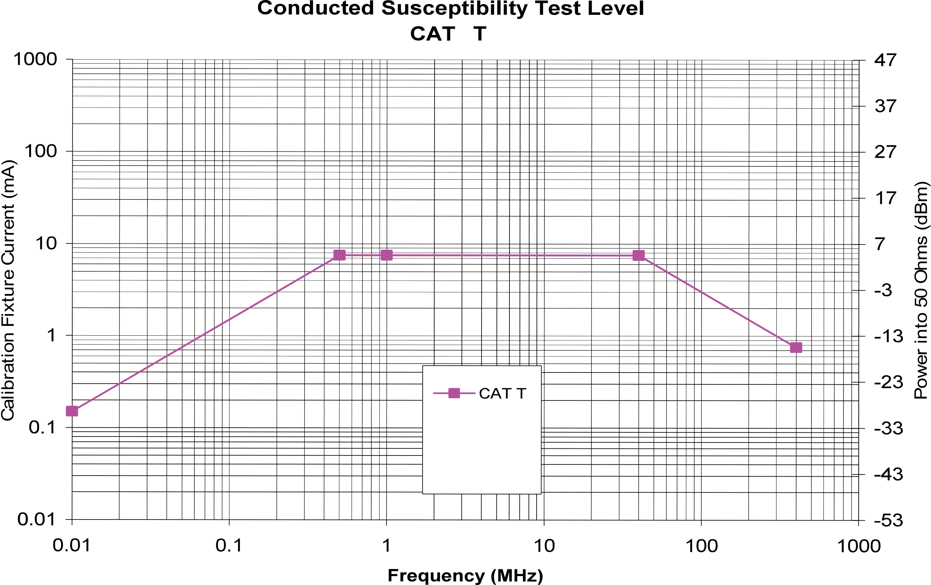

Figure 14 – Conducted RF Susceptibility Test Levels

# BASIC EUT TEST SETUP AND OPERATIONAL MODES

## OPERATIONAL MODES

### NORMAL OPERATIONAL MODE

115VAC Power Input applied to Monitor. *[Video input]* video content showing on visual display. §6.2 & §6.3 show operation mode setup for environmental and EMC test setups.

### NON-OPERATIONAL MODE

Monitor will be in the OFF mode. The monitor can be turned off either by fulling disconnecting AC power or soft OFF from IR remote power button.

## BASIC TEST SETUP

### ENVIRONMENTAL TEST SETUP

#### *[INPUT SPECIFIC, ENVIRONMENTAL TEST SETUP DIAGRAM]*

Figure 15 – [Input specific environmental test setup]

#### *[EUT SPECIFIC OR GENERAL TEST POWER CABLE ASSEMBLY DRAWING]*

Figure 16 – [Environmental test power cable assembly]

### EMC TEST SETUP

#### *[INPUT SPECIFIC, EMC TEST SETUP DIAGRAM]*

Figure 17 – [Input specific EMC test setup diagram]

#### GENERAL TEST SETUP WITH LISNS

Figure 18 – General test setup for chamber with LISNs

#### *[EUT SPECIFIC OR GENERAL EMC TEST POWER CABLE]*

Figure 19 – [EUT specific EMC test power cable]

## TEST SPECIFIC SETUPS

### VIBRATION, OPERATIONAL SHOCKS & CRASH SAFETY IMPULSE

#### TOP TO BOTTOM AXIS TEST SETUP



Figure 20 – Top to Bottom Axis Test Setup

#### SIDE TO SIDE AXIS TEST SETUP



Figure 21 – Side to Side Axis Test Setup

#### FRONT TO REAR AXIS TEST SETUP



Figure 22 – Front to Rear Axis Test Setup

### DYNAMIC BALL IMPACT

#### Ball Impact Test Setup

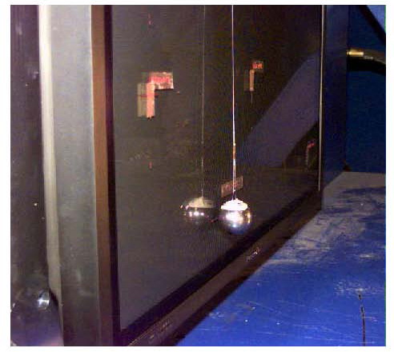

Figure 23 – Ball Impact Test Setup Photo

#### Typical Ball Impact Test Layout

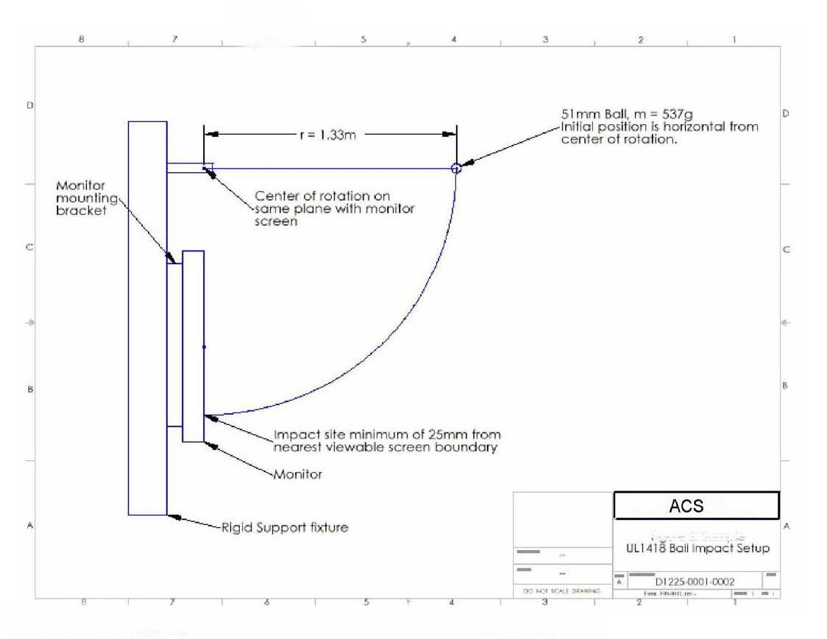

r = 2.16m

Figure 24 – Typical Ball Impact Test Layout

### STATIC ABUSE LOAD

#### STATIC ABUSE LOAD TEST SETUP

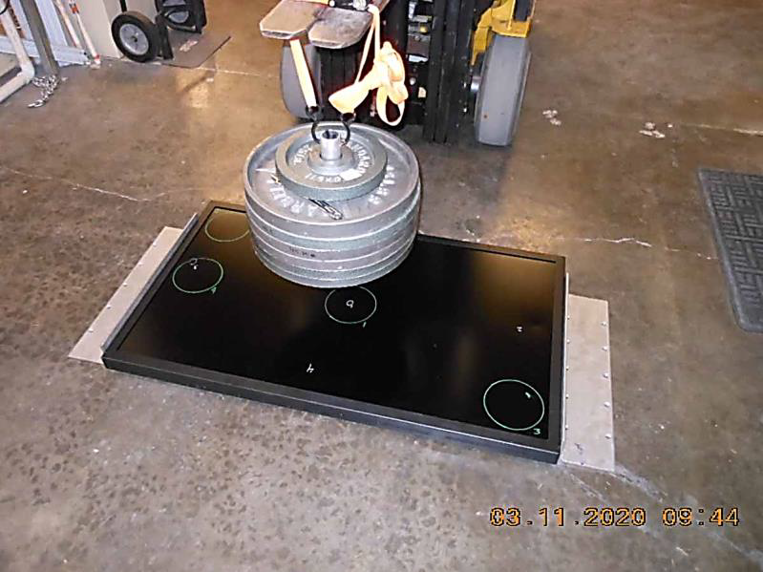

Figure 25 – Static Abuse Load Test Setup Photo

#### LOAD CONFIGURATION POINTS

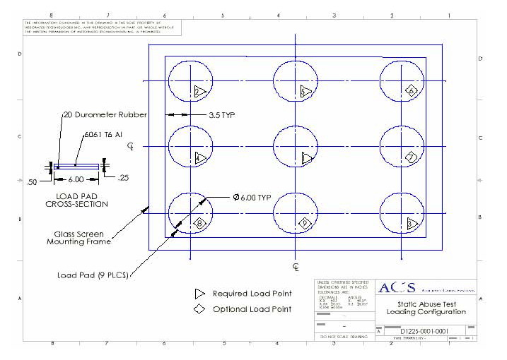

Figure 26 – Load Configuration Points

### CRASH SAFETY SUSTAINED

The test article should be mounted to the centrifuge in the orientation to produce an acceleration in the opposite direction as the specified inertia load.

#### UP POSITION TEST SETUP

The test set-up for the “Up” inertia load is shown in Figure 27. The centripetal acceleration may be produced by a positive, or negative, angular velocity about either the “x” or “y” rotation axis. R measured to bottom surface of monitor.



Figure 27 – Test set-up for sustained “Up” inertia load

#### DOWN POSITION TEST SETUP

The test set-up for the “Down” inertia load is shown in Figure 28. The centripetal acceleration may be produced by a positive, or negative, angular velocity about either the “*x*” or “*y*” rotation axis. R measured to top surface of monitor.

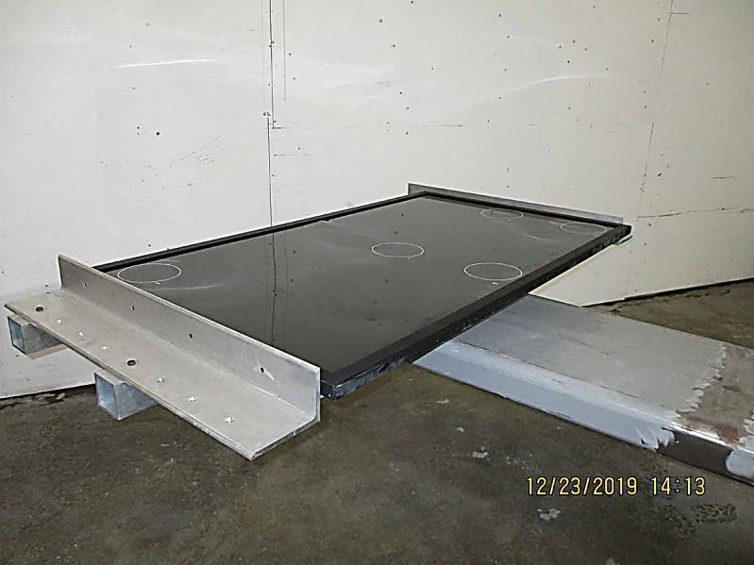

Figure 28 – Test set-up for sustained “Down” inertia load

#### SIDE POSITION TEST SETUP

The test set-up for the side inertia load to “Side” is shown in Figure 29. The centripetal acceleration may be produced by a positive, or negative, angular velocity about either the “*x*” or “*z*” rotation axis.

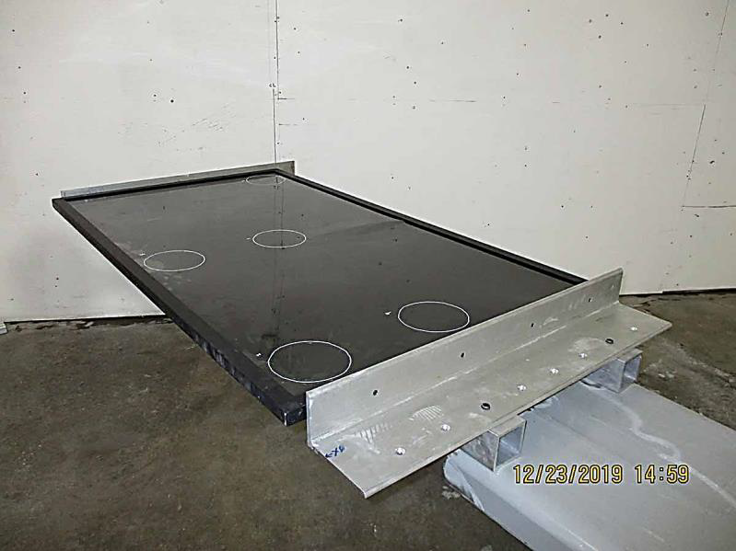

Figure 29 – Test set-up for sustained “Side” inertia load acting in the +y direction

#### SIDE – OPPOSITE POSITION TEST SETUP

The test set-up for the side inertia load to “Side – Opposite” is shown in Figure 30. The centripetal acceleration may be produced by a positive, or negative, angular velocity about either the “*x*” or “*z*” rotation axis.

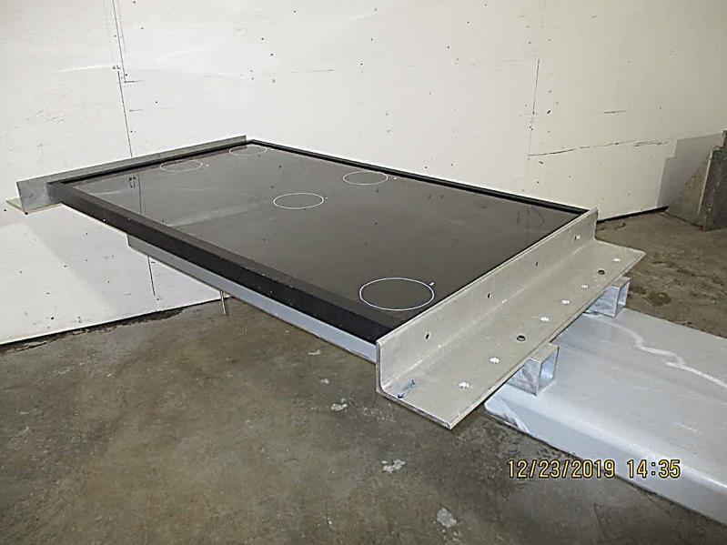

Figure 30 – Test set-up for sustained “Side - Opposite” inertia load acting in the -y direction

#### FORWARD POSITION TEST SETUP

The test set-up for the Forward inertia load is shown in Figure 31. The centripetal acceleration may be produced by a positive, or negative, angular velocity about either the “*y*” or “*z*” rotation axis.

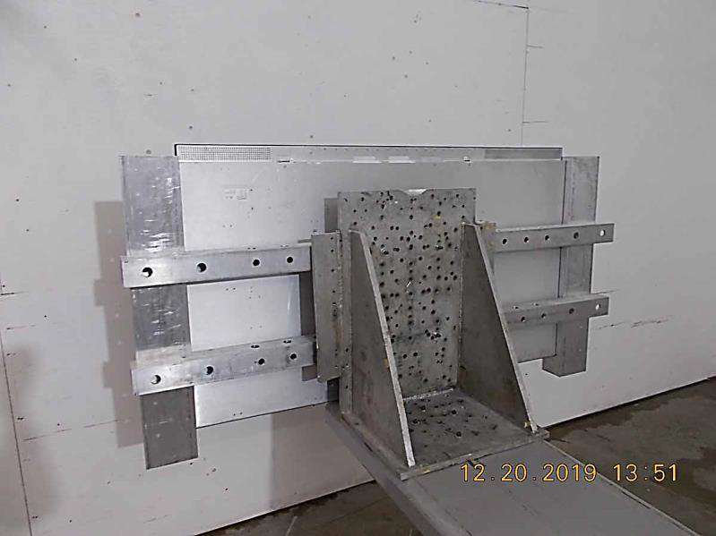

Figure 31 – Test set-up for sustained “Forward” inertia load

#### AFT POSITION TEST SETUP

The test set-up for the Aft/Forward #2 inertia load is shown in Figure 32. The centripetal acceleration may be produced by a positive, or negative, angular velocity about either the “*y*” or “*z*” rotation axis. Dimension R measured to back face of monitor.

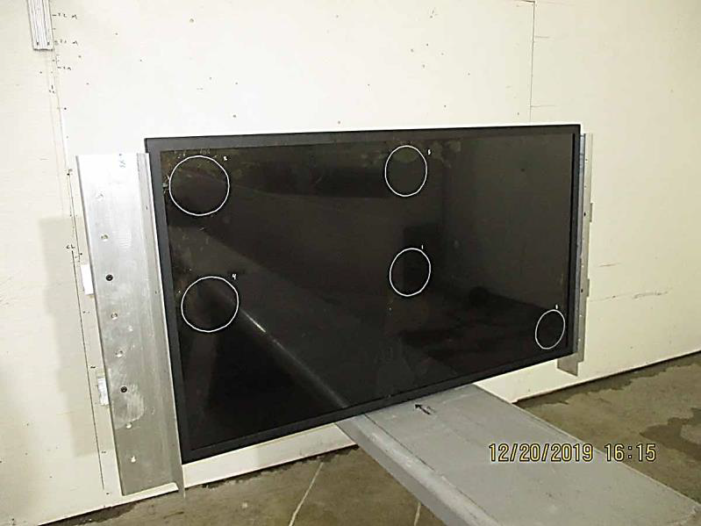

Figure 32 – Test set-up for sustained “Aft” inertia load

### RF EMISSIONS

#### RADIATED RF EMISSIONS TEST SETUP

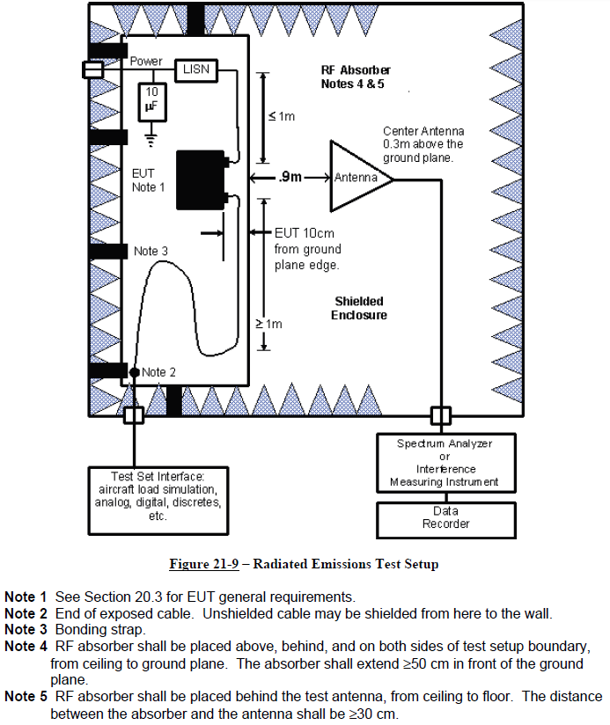

Figure 33 – Radiated RF Emissions Test Setup

Note 1 EUT set up as described in DO-160 (rev G), section 20.3.a, unless otherwise specified.

Note 2 RF absorber shall be placed above, behind, and on both sides of test setup boundary,

from ceiling to ground plane. The absorber shall extend >50 cm in front of the ground plane.

Note 3 RF absorber shall be placed behind the antenna, from ceiling to floor.

#### CONDUCTED RF EMISSIONS TEST SETUP



Figure 34 – Conducted RF Emissions Test Setup

Note 1 EUT set up as described in DO-160 (rev G), section 20.3.a, unless otherwise specified.

Note 2 RF absorber shall be placed above, behind, and on both sides of test setup boundary,

from ceiling to ground plane. The absorber shall extend >50 cm in front of the ground plane.

Note 3 RF absorber shall be placed behind the antenna, from ceiling to floor.

### POWER INPUT

#### VOLTAGE AND FREQUENCY (AC)

Programmable AC Power Supply

EUT

Oscilloscope

Chassis GND, if required

Figure 35 – Typical Setup for Voltage and Frequency (AC) Tests

#### VOLTAGE MODULATION (AC)

Programmable AC Power Supply

EUT

Oscilloscope

Chassis GND, if required

Figure 36 – Typical Setup for Voltage Modulation (AC) Tests

#### FREQUENCY MODULATION (AC)

Programmable AC Power Supply

EUT

Oscilloscope

Chassis GND, if required

Figure 37 – Typical Setup for Frequency Modulation (AC) Tests

#### MOMENTARY POWER INTERRUPTIONS (AC)

Programmable AC Power Supply

EUT

Oscilloscope

Chassis GND, if required

Figure 38 – Typical Setup for Momentary Power Interruptions (AC) Tests

#### NORMAL SURGE VOLTAGE (AC)

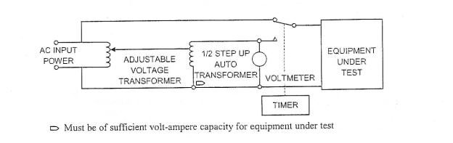

Figure 39 – Typical Setup for Normal Surge Voltage (AC) Tests

#### NORMAL FREQUENCY TRANSIENTS (AC)



Figure 40 – Typical Setup for Normal Frequency Transients (AC) Tests

#### VOLTAGE DC CONTENT (AC)



Figure 41 – Typical Setup for Voltage DC Content (AC) Tests

#### VOLTAGE DISTORTION (AC)



Figure 42 – Typical Setup for Voltage Distortion (AC) Tests

#### ABNORMAL VOLTAGE AND FREQUENCY LIMITS IN STEADY STATE (AC)



Figure 43 – Typical Setup for Abnormal Voltage and Frequency Limits in Steady State (AC) Tests

#### MOMENTARY UNDERVOLTAGE OPERATION (AC)



Figure 44 – Typical Setup for Voltage Distortion (AC) Tests

#### ABNORMAL SURGE VOLTAGE (AC)



Figure 45 – Typical Setup for Abnormal Surge Voltage (AC) Tests

### VOLTAGE SPIKE

#### Voltage Spike Test Setup



Figure 46 – Voltage Spike Test Setup

### AF CONDUCTED SUSCEPTIBILITY

#### AF Conducted Susceptibility Test Setup



Figure 47 – AF Conducted Susceptibility Test Setup

### INDUCED SIGANL SUSCEPTIBILTY

#### AF MAGNETIC FIELD INDUCED INTO EQUIPMENT



Figure 48 – Typical Setup for AF Magnetic Field Induced into Equipment

#### MAGNETIC FIELDS INDUCED INTO INTERCONNECTING CABLES



Figure 49 – Typical Setup for AF Magnetic Field Induced into Interconnecting Cables

#### ELECTRIC FIELD INDUCED INTO INTERCONNECTING CABLES



Figure 50 – Typical Setup for Electric Field Induced into Interconnecting Cables

#### SPIKES INDUCED INTO INTERCONNECTING CABLES

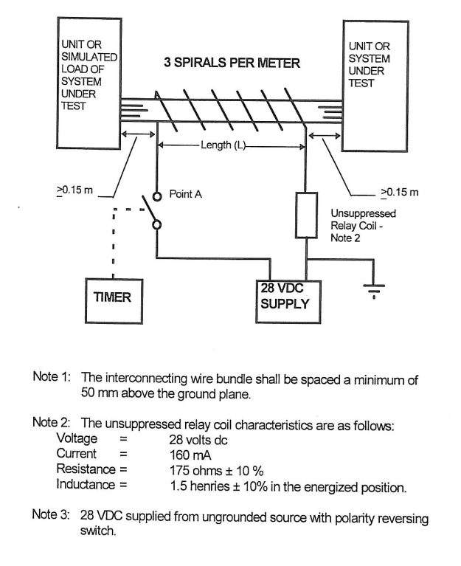

Figure 51 – Typical Setup for Spikes Induced Interconnecting Cables

### RF SUSCEPTIBILITY

#### RADIATED RF SUSCEPTIBILITY TEST SETUP

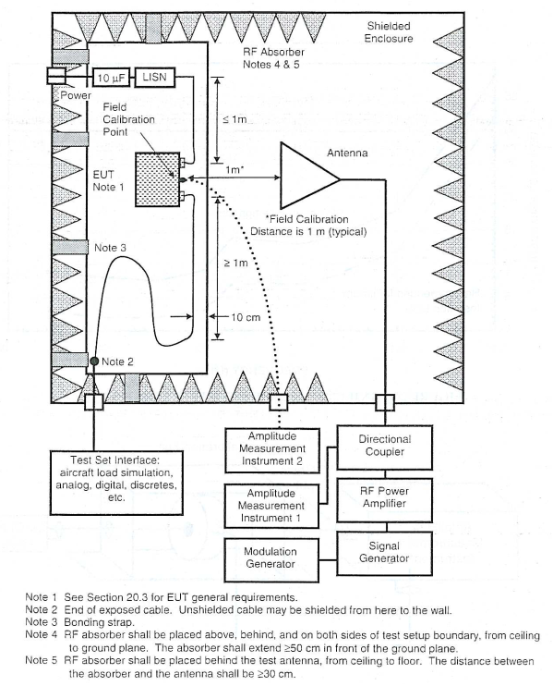

Figure 52 – Typical Setup for Radiated RF Susceptibility

#### CONDUCTED RF SUSCEPTIBILITY CALIBRATION SETUP

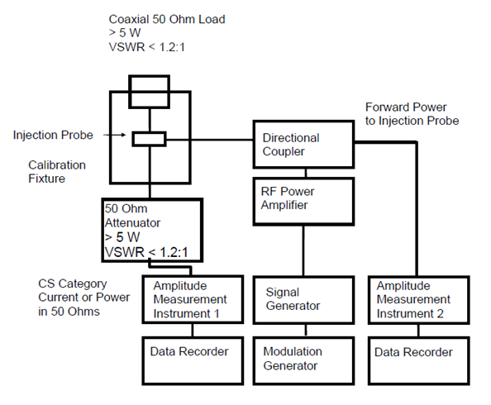

Figure 53 – Conducted RF Susceptibility Calibration Setup

#### CONDUCTED RF SUSCEPTIBILITY TEST SETUP

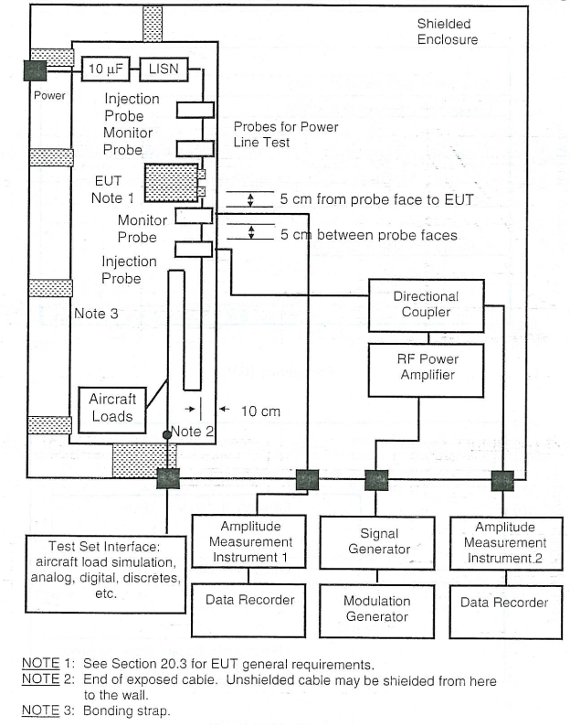

Figure 54 – Typical Setup for Conducted RF Susceptibility

# TEST CRITERIA

## GROUP 1 PERFORMANCE TESTS

Group 1 Performance Tests shall be performed before and after each environmental test. Group 1 performance tests shall be run following any repairs to the EUT.

### Verification Method

1. Verify HDMI video is displayed on EUT display.
2. Verify IR sensor function by sending “on” and “off” commands via IR remote when/if test setup allows.

### PASS CONDITIONS

HDMI video is displayed on EUT display.

### FAIL CONDITIONS

1. Degradation in quality of HDMI video displayed on LCD panel screen.
2. Artifacts such as ghosting, cross-hatching, and synchronization errors.
3. Backlight bulb failures such that one or more bulbs are non-functioning.
4. Monitor goes into non-operational mode and/or is not able to enter operational mode.
5. The EUT does not maintain safe conditions throughout the test including visible arcs, sparks, smoke or fire.

## GROUP 1 PERFORMANCE MONITORING

When the EUT is energized the following DO-160G tests shall require periodic visual monitoring.

Note: During certain tests the test apparatus may not allow for visual monitoring.

1. Temperature and Temperature Variation
2. Altitude
3. Decompression
4. Vibration
5. Operational Shocks
6. Voltage Spike
7. Lightning Induced Transient Susceptibility

### Pass Conditions

During the running of DO-160G tests, the following Group 1 Performance Monitoring criteria shall be deemed acceptable:

1. HDMI video is displayed on the EUT screen

### Fail Conditions

During the running of DO-160G tests, the following Group 1 Performance Monitoring criteria shall be deemed unacceptable:

1. Degradation in quality of HDMI video displayed on LCD panel screen.
2. Artifacts such as ghosting, cross-hatching, and synchronization errors.
3. Backlight bulb failures such that one or more bulbs are non-functioning.
4. Monitor goes into non-operational mode and/or is not able to enter operational mode.
5. The EUT does not maintain safe conditions throughout the test including visible arcs, sparks, smoke or fire.

## VIBRATION/OPERATIONAL SHOCK TEST

### PASS CONDITIONS

1. No physical damage including cracks, detached or loose parts

### FAIL CONDITIONS

1. EUT mounting means does not hold test load in position.
2. EUT becomes a hazard (breaks free from the test apparatus).

## CRASH SAFETY SUSTAINED/IMPULSE TEST

### PASS CONDITIONS

1. Bending and distortion of the mounts is allowed.
2. Internal loose screws are allowed, as long as the screws are not for structural purposes (i.e. mounting bracket screws).

### FAIL CONDITIONS

1. EUT mounting means does not hold test load in position.
2. EUT becomes a hazard (breaks free from the test apparatus).

## DYNAMIC BALL IMPACT/STATIC ABUSE LOAD TEST

### PASS CONDITIONS

1. All glass must be contained inside the EUT in the event of breakage. Glass is able to crack but cannot be expelled from the unit.
2. Maintains PASS CONDITIONS after Crash Safety Sustained test.

### FAIL CONDITIONS

1. Glass is expelled from the unit.
2. Broken glass creates a sharp, exposed edge (outside of display film).

## RADIATED/CONDUCTED RF EMISSIONS

### PASS CONDITIONS

1. Emissions are below category requirements.

### FAIL CONDITIONS

1. Emissions exceed category requirements.

# RECOMMENDED FORMS & REPORTING

## QUALIFICATION TEST DATA SHEET TEMPLATE (optional)

This form may be used for test data or the test lab may use their own if available

|  |  |  |  |
| --- | --- | --- | --- |
| QUALIFICATION TEST DATA SHEET | | | |
| QUAL TEST SECTION: |  | FAA PROJECT #: |  |
| TEST TYPE (ENV, EMC): |  | ACS REP: |  |
| TEST PLAN DOC NO & REV: |  | TEST TECHNICIAN: |  |
| TEST PLAN DOC SECTION: |  | TEST START DATE / TIME: |  |
| TEST PURCHASE ORDER NO: |  | TEST END DATE / TIME: |  |
| EUT INFORMATION/DESCRIPTION | | | |
| PART NUMBER: | Part Number | SERIAL NUMBER: |  |
| REV AND/OR MOD: |  | MOD LEVEL (POST TEST, if modified): |  |
| LAB EQUIPMENT | MANUFACTURER/MODEL | SERIAL NO. | CALIBRATION DATE |
|  |  |  |  |
|  |  |  |  |
|  |  |  |  |
|  |  |  |  |
|  |  |  |  |
|  |  |  |  |
|  |  |  |  |
|  |  |  |  |
|  |  |  |  |

|  |  |  |  |  |  |
| --- | --- | --- | --- | --- | --- |
| TEST OBSERVATION | | MODE OR ORIENTATION | PASS/FAIL | PASS or FAIL CONDITION(S) OBSERVED | |
| PRE-TEST PERFOMANCE TEST | |  |  |  | |
| PERFORMANCE MONITORING | |  |  |  | |
| POST-TEST EVALUATION | |  |  |  | |
| POST PERFORMANCE TEST | |  |  |  | |
| PRE-TEST PERFOMANCE TEST | |  |  |  | |
| PERFORMANCE MONITORING | |  |  |  | |
| POST-TEST EVALUATION | |  |  |  | |
| POST PERFORMANCE TEST | |  |  |  | |
| PRE-TEST PERFOMANCE TEST | |  |  |  | |
| PERFORMANCE MONITORING | |  |  |  | |
| POST-TEST EVALUATION | |  |  |  | |
| POST PERFORMANCE TEST | |  |  |  | |
| PRE-TEST PERFOMANCE TEST | |  |  |  | |
| PERFORMANCE MONITORING | |  |  |  | |
| POST-TEST EVALUATION | |  |  |  | |
| POST PERFORMANCE TEST | |  |  |  | |
| POST-TEST ASSESSMENT | | | | | |
| FAILURES AS DEFINED BY TEST PLAN/PROCEDURE: |  | | | | |
| DEVIATIONS: |  | | | | |
| FINAL OBSERVATIONS (PASS/FAIL): |  | | | | |
| WITNESSES | | | | | |
| FAA DAR/ODA WITNESS: | ORGANINZATION: | | | | TITLE: |
| FAA DER WITNESS: | ORGANINZATION: | | | | TITLE: |
| ADDITIONAL WITNESS: | ORGANINZATION: | | | | TITLE: |

|  |  |
| --- | --- |
| PRE-TEST PHOTO | |
| EUT PN: | Part Number |
| EUT SN: |  |
| EUT REV / MOD: |  |
| TEST SECTION / DESC.: |  |
|  | |
|  | |

|  |  |
| --- | --- |
| POST-TEST PHOTO | |
| EUT PN: | *Part Number* |
| EUT SN: |  |
| EUT REV / MOD: |  |
| TEST SECTION / DESC.: |  |
|  | |
|  | |

|  |  |
| --- | --- |
| TEST DATA | |
| EUT PN: | *Part Number* |
| EUT SN: |  |
| EUT REV / MOD: |  |
| TEST SECTION / DESC.: |  |
|  | |
|  | |

## TEST WITNESS SIGNOFF SHEET

When test witnessing is required, the form in this section may be used for test witness signoff.

| QUALIFICATION TEST WITNESS SHEET | | | | | | | | | | |
| --- | --- | --- | --- | --- | --- | --- | --- | --- | --- | --- |
| FAA PROJECT #: | |  | | | FAA DAR/ODA WITNESS: | | | |  | |
| QUAL TEST DOC NO. / REV / SECTION: | |  | | | TEST TECHNICIAN: | | | |  | |
| SOURCE TEST SECTION / EQUIPMENT CATEGORY: | |  | | | TEST START DATE / TIME: | | | | TEST END DATE / TIME: | |
| EUT INFORMATION/DESCRIPTION | | | | | | | | | | |
| PART NUMBER: | | *Part Number* | | | SERIAL NUMBER: | | | |  | |
| REV AND/OR MOD: | |  | | | MOD LEVEL (POST TEST): | | | |  | |
| ITEM | | | PASS | FAIL | | PASS/FAIL CONDITION(S) OBSERVED or NOTES | | | |
| QUALIFICATION TEST RESULT | | |  |  | |  | | | |
| WITNESSES | | | | | | | | | | |
| TITLE: | NAME: | | | | | | ORGANIZATION: | | | |
| SIGNATURE: | | | | | | | | DATE: | | |
| TITLE: | NAME: | | | | | | ORGANIZATION: | | | |
| SIGNATURE: | | | | | | | | DATE: | | |
| TITLE: | NAME: | | | | | | ORGANIZATION: | | | |
| SIGNATURE: | | | | | | | | DATE: | | |
| TITLE: | NAME: | | | | | | ORGANIZATION: | | | |
| SIGNATURE: | | | | | | | | DATE: | | |

# EUT SPECIFIC DATA

## BLOCK DIAGRAM

Figure 55 – Functional Block Diagram

## OUTLINE DRAWING

Figure 56 – Outline Drawing

## CONNECTOR DEFINITIONS

### POWER INPUT / ARINC 722 CONTROL / RS232 INPUT

### [Input Type] INPUT

### [Input Type] INPUT